YEAR 6 READING CURRICULUM
 | AUTUMN | SPRING | SUMMER
BOOK STUDY | 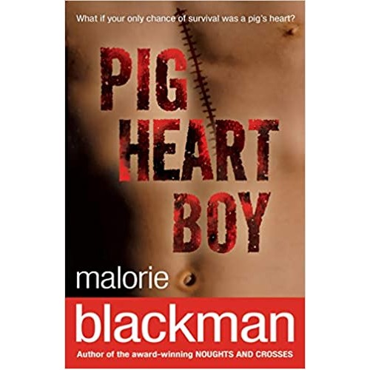  Plague of reading: Complexity of the narrator  Story Type: No 1 Overcoming the Monster and No 7 Rebirth  Curriculum Link: Science | 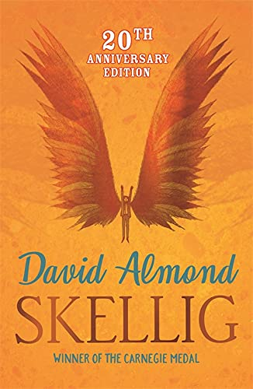 Plague of reading: Complexity of Plot/symbol  Story Type: No 1 overcoming the monster & No 7 rebirth  School Ethos – tolerance & respect for those who differ from them | 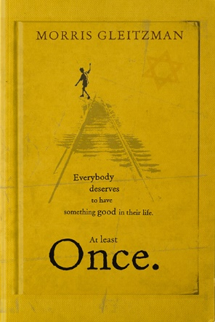 Plague of reading: Complexity of the narrator  Story Type: No 1 overcoming the monster, No 6 Tragedy and No 7 Rebirth  Curriculum link: History
POETRY | I am a Minotaur | The Jabberwocky by Lewis Carroll  The Tyger by William Blake Resistant texts | Tintern Abbey William Wordsworth  The Princess by Alfred Lord Tennyson
PERFORMANCE POETRY | An Ode to the Ancient Greeks | Fire, burn & Cauldron Bubble by William Shakespeare  Jack and the Beanstalk - Roald Dahl  Fuss Fuss Fuss or Goldilocks Rap – James Carter  Goldilocks on CCTV - John Agard | IF by Rudyard Kipling
NON-FICTION | Link to curriculum:  Nelson Mandela biography – Ethos - Resilience to achieve, world issues, responsibilities as a society. | Link to curriculum:  Moth by Isobel Thomas – Science  What Mr Darwin Saw Science  Earth’s Natural Biomes – Geography | Link to curriculum:  World War 2 texts - History
EXTRACTS | Journey to Jo’burg  Ethos - tolerance & respect for those who differ from them  A Christmas Carol  Non-Linear time sequence/Archaic text  Holes by Louis Sachar  Non-linear time sequence | Archaic texts  Just So stories - Science  Swallows and Amazons  Macbeth  War Horse - History | Archaic texts  Peter Pan  Alice’s Adventures in Wonderland  Five children and It  Young, Gifted and Black by Jamia Wilson  Ethos – An understanding of world issues and their responsibilities as a society. Tolerance of and respect for those who differ from them. Equality of opportunity and value diversity
KEY AUTHORS | Malorie Blackman | William Shakespeare | Morris Gleitzmann

