YEAR 5 READING CURRICULUM
 | AUTUMN | SPRING | SUMMER
BOOK STUDY | 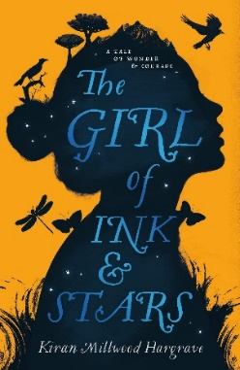  Plague of reading: Complexity of plot/symbol  Story Type: Fantasy.  Overcoming the monster, voyage and return  School Ethos – tolerance & respect for those who differ from them | 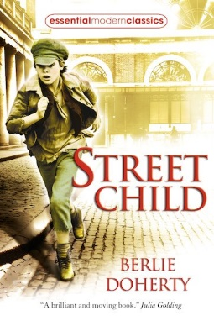  Plague of reading: Archaic text  Story Type: Rags to riches, Tragedy and Overcoming the monster  Curriculum link: History | 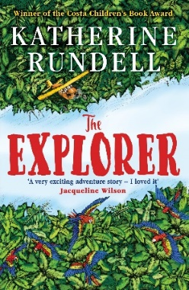  Plague of reading: Narratively complex  Story Type: Overcoming the monster, Voyage and return, and Rebirth  Curriculum link: Geography
POETRY | A Kid in My Class Rachel Rooney and Chris Riddell  Ethos – aspiration. Resilience to achieve, tolerance & respect for those who differ from them. | Overheard in a Tower Block – poems by Joseph Coelho  Ethos/PSHE - celebrating differences  Spaced out – Science  Resistant texts | The Pobble who has no toes – Edward Lear  Resistant text  Dreams – Langston Hughes  Complexity of plot/symbol
PERFORMANCE POETRY | Be the change – poems to help save the world  PSHCE – environmental issues. Ethos – responsibilities as a society. Understanding of world issues.  A Christmas Carol – Charles Dickens  Archaic text, non-linear time sequence | Daffodils – William Wordsworth  Complexity of plot/symbol  Cloud Busting- Malorie Blackman  Resistant text | The Highwayman – Alfred Noyes  Archaic text
NON-FICTION | Elizabeth I-Stephanie Turnbull & Colin King  Eyewitness: Tudor -DK  Tracking Down: The Tudors and Stuarts in Britain  History  Oceanarium  Loveday Trinick & Teagan White  Earth's Incredible Oceans  Jess French & Claire McElfatrick  Geography | Desert Biomes around the world – M M Eboch  Forest Biomes around the world - M M Eboch  Biomes – Geographics  What A Waste: Rubbish, Recycling, and Protecting our Planet – Geography and PSHCE – environmental issues. Ethos – responsibilities as a society.  Mae Jemison – blast off into space like – Science  Ethos – aspiration. Resilience to achieve & respect for those who differ from them.  Victorians(Eyewitness) - Ann Kramer  History | The History Detective Investigates: Mayan Civilization  Clare Hibbert  The Maya and Chichén Itzá (Time Travel Guides)  Ben Hubbard  History  Amazing Rivers  Julie Vosburgh Agnone & Kerry Hyndman  Amazon River  Sangma Francis & Romolo D'Hipolito  Geography
EXTRACTS | Treason – Berlie Doherty  Diver’s Daughter – A Tudor Story – History  The Story of Ruby Bridges – Robert Coles School Ethos – acceptance & respect for those who differ from them | Nowhere Emporium- Ross Mackenzie- Non-linear sequence  Hidden Figures: The True Story of Four Black Women and the Space Race- Simon Bartram  Science and Ethos – aspiration. Resilience to achieve, tolerance & respect for those who differ from them.  Gaslight- Eloise Williams- History | Wind in the Willows- Kenneth Grahame Archaic text  The Chocolate Tree – A Mayan Folktale – History  Wonder - R.J. Palacio  Narrative complexity,  The Great Kapok – Lynne Cherry  Geography
AUTHORS | B B Alston | Berlie Doherty  Onjali Q. Raúf | Katherine Rundell

