YEAR 4 READING CURRICULUM
 | AUTUMN | SPRING | SUMMER
BOOK STUDY | 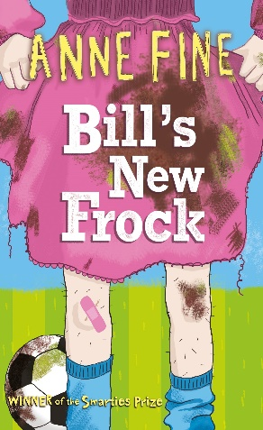  Year 3/4 recommended read  Story Type: Overcoming the monster & journey and return  School Ethos- Promote tolerance and respect for those who differ from them | 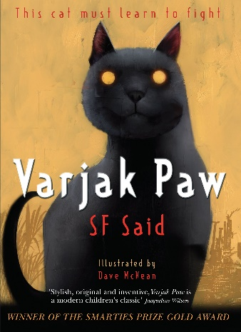  Year 3/4 recommended read  Story Type: Overcoming the monster, rebirth & the quest | 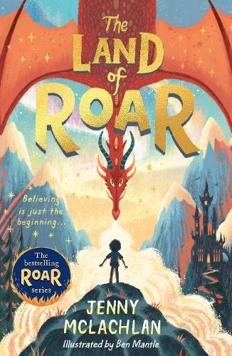  Year 3/4 recommended read  Story Type: Overcoming the monster & voyage and return
POETRY | How Doth the Little Crocodile  Archaic language | The Magic Box  Resistant text | Please Mrs Butler  Resistant text
PERFORMANCE POETRY | Catch A Little Rhyme  Figurative/symbolic text | The Magic Box  Resistant text | Last Night I Saw a Hedgehog and Squirrel in Winter  Figurative/symbolic text
NON-FICTION | Rivers (Where on Earth?) - Geography | Eyewitness Volcano & Earthquake - Geography | Viking Longship - History
EXTRACTS | Firework maker’s daughter non-linear  I Was a Rat (non-linear)  School Ethos-promoting equality of opportunity and value diversity | Eva Ibbotson – Journey to the river sea non-linear  The dragonfly pool non-linear  Not just a witch non-linear  Rumaysa: Ever After and A Fairytale non-linear | Podkin One-ear (narratively complex)  Edward Tulane (narratively complex)  School Ethos- An understanding of world issues and responsibilities of society  Promote independent, resilient learners  Because of Winn-Dixie (narratively complex)  Promote equality and Justice  Promote tolerance and respect of others who differ from them
AUTHORS | Philip Pullman  Anne Fine | Eva Ibbotson  Radiya Hafiza | Kate DiCamillo

