YEAR 3 READING CURRICULUM
 | AUTUMN | SPRING | SUMMER
BOOK STUDY | 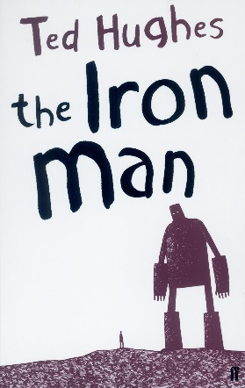  Plague of reading: Symbolic Text, Complexity of Plot  Story Type:  Overcoming the enemy / monster  Voyage and return | 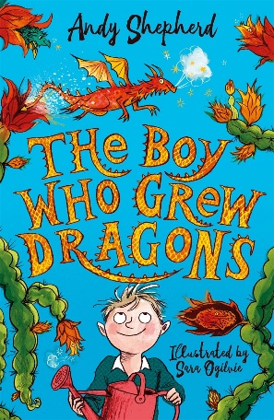  Plague of reading:  Story Type:  Overcoming the monster / enemy  Rebirth | 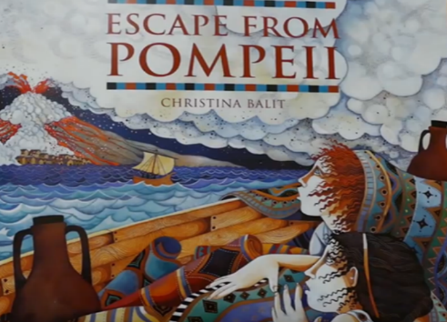  Plague of reading:  Story Type:  Overcoming the enemy / monster  Tragedy
POETRY | Topsy Turvy World – William Brightly Rands  Archaic texts | Various – Benjamin Zephaniah  School Ethos – tolerance & respect for those who differ from them | Dream Variations – Langston Hughes  Complexity of plot / symbol and Archaic texts
PERFORMANCE POETRY | The Schoolkid’s Rap – John Foster | Nature Trail by Benjamin Zephaniah  School Ethos – tolerance & respect for those who differ from them | Adventures of Isabel Ogden Nash
NON-FICTION | Forces and movement – Peter Riley: Science  Stone age to Iron Age – Clare Hibbert: History  DK Find out – Stone Age : History  DK Life in the Stone Age : History | Range of Egyptian non fiction books: History  Range of Rivers non fiction books: Geography | Roman Forts-Margaret Mulvihill: History  The Roman Chronicle- Literacy world: History
EXTRACTS | Butterfly Lion – Michael Morpurgo  Non-linear time sequences | I, Cosmo – Carlie Sorosiak  Complexity of the narrator | Erica’s Elephant – Sylvia Bishop
AUTHORS | Ted Hughes  William Brightly Rands  Michael Morpurgo | Andy Shepherd  Carlie Sorosiak  Benjamin Zephaniah | Christina Balit  Langston Hughes  Sylvia Bishop

