YEAR 2 READING CURRICULUM
 | AUTUMN | SPRING | SUMMER
CORE BOOKS | 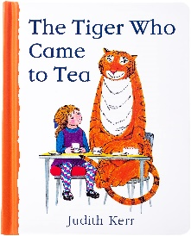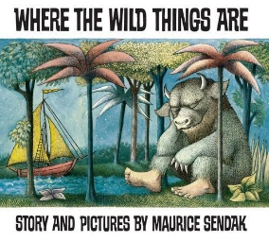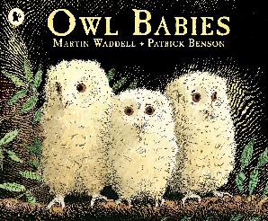  Complexity of the plot  The Day the Crayons Quit – Drew Daywalt  The Twits - Roald Dahl  Nicky and the Twins – Tony Bradburn  Fluff the farting fish – Michael Rosen  The polar express – Chris Van Allsburg  Can I build another me? – Shinsuke Yoshitake  Where the forest meets the sea – Jeannie Baker  Girls wonder’s winter adventures – Malorie Blackman  My monster and me – Nadiyah Hussain  The Smartest Giant in town – Julie Donaldson  How Big is a million? – Anna Milbourne and Serena Riglietti  The Deductive detective – Brian Rock  Two Ways to count to 10 – Ruby Dee  The Magic paintbrush – Julia Donalson  The snowy reindeer – Paula Harrisson  Voices in the Park- Anthony Brown | 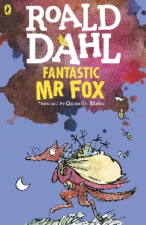  Complexity of the narrator  Amazing Grace – Mary Hoffman  Hostage – Malorie Blackman  No longer alone – Joseph Coleho  Gorilla – Anthony Browne  Frog and Toad together – Arnold Lobel  Traction man – Mini Grey  Who’s afraid of the Big Bad book – Lauren Child  Flat Stanley – Jeff Brown  The Name jar – Yangsook Choi  The Lorax – Dr Seuss  Vlad and the Great fire of London- Kate Cunningham  Fire fire  What the Ladybird Heard – Julia Donaldson  Everyone can learn math – Alice Aspinall  Miss Penny says Prove it! – Lynda Brennan  Jayla number naviagator – Lynda Brennan | 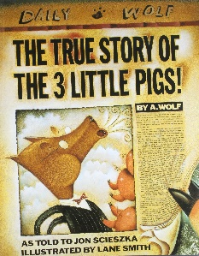  Complexity of the narrator  My two grandads – Floella Benjamin  The last wolf – Mini Grey  The rabbits – John Marsden & Shaun Tan  Choosing Crumble – Michael Rosen  Giraffes can’t dance – Giles Andreae  What the Ladybird Heard Next– Julia Donaldson  Pumpkin Soup – Helen Cooper  Supertato – Paul Linnet and Sue Hendra  The Magic Finger - Roald Dahl  Pastry school in Paris – Cindy Neuschwander  A remainder of one – Elinor J Pinczes  The wishing club -Donna Jo Napoli  Knights handbook – Sam Taplin
POETRY | Archaic text  Quick let’s get out of here – Michael Rosen  Bad, bad cats – Roger McGough | Crazy Mayonnaisy Mum – Julia Donaldson  Chocolate cake- Michael Rosen | Archaic text  The Cat in the Hat – Dr Seuss  All the wild wonders – Wendy Cooling (various poets)  Revolting Rhymes – Roald Dahl
PERFORMANCE POETRY | The Owl and the pussy cat – Edward Lear | No breathing in class – Michael Rosen | Resistance text  Ning, Nang, Nong
NON-FICTION | Link to curriculum: History  Titanic fact file  Taking flight – Adam Hancher  Look inside our world – Emily Bone  Ways into history: Brunel the great engineer – Sally Hewitt | Link to curriculum: History  The Great fire of London – Jenny Powell  The Great Fire of London – Liz Gogerly | Link to curriculum: History  The stories of castles – Lesley Sims  See Inside castles – Katie Daynes  Castles (Big Cat book) – Maggie Freeman
AUTHORS | Roald Dahl  Michael Rosen  Julia Donaldson  Malorie Blackman  Floella Benjamin

