YEAR 1 READING CURRICULUM
Autumn |  | Spring |  | Summer
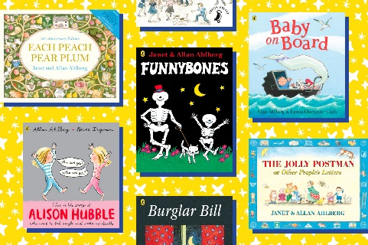 |  | 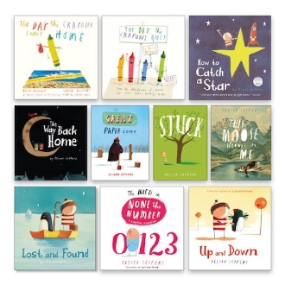 |  | 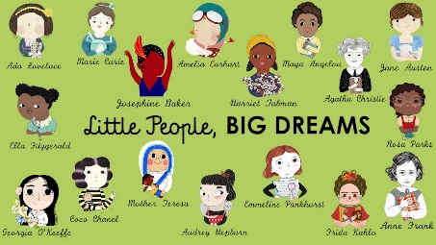
Core texts | Core nursery rhymes | Core texts | Core nursery rhymes | Core texts | Core nursery rhymes
Here We Are  The Jolly Postman and Other People’s Letters  Goldilocks and the three Bears  Jack and the Beanstalk  The Giant of Jum  Hansel and Gretel  The Three Little Pigs  The True Story of the 3 Little Pigs  The Three Little Wolves and the Big Bad Pig  Wild  Spinderella  Wonderful Earth  Room on the Broom  The Gruffalo  The Tiger who Came to Tea  The Giraffe the Pelly and Me  Kippers Toy Box  Lost in the Toy Museum: An Adventure  The Rainbow Fish  We Are Together  It’s OK to be Different  Tidy  Riley Knows He Can  Funny Bones collection  Each Peach Pear Plum  Burglar Bill  Cops & Robbers  Happy Families collection  Chicken Clicking  HerStory: Women and Girls Who Shook the World  History of Toys (Big Book)  Toys around the world  Toys and Games  Twinkle Twinkle little star  Please Mrs Butler | Clapping games  Patty Cake  Double, Double  Say, say oh playmate  Miss Mary Mack Mack A sailor went to sea. | The Snail and the Whale  Beegu  Whatever Next!  The Way Back Home  The Day the Crayons Quit  How to Catch a star  Lost and Found  Can I build another me?  Omar, the Bees and Me  Spectacular Space  Man on the Moon  Astronaut  Star in a Jar  Chickens can’t see in the dark  The Tiny Seed  Mr Big  Mae Among the Stars  Goodnight Spaceman  Sam Plants a Sunflower  Ten Seeds  Katie and the Starry Night  Look Up  Busy Spring, Nature Wakes Up  Little People, Big Dreams  Fantastically Great Women who Worked Wonders  Let’s Grow  Why Do Plants Grow in Spring? Stepping Stones  The Poetry Chest  Book of Animal Poetry by National Geographic  Animal Poems  Little People, Big Dreams | Performance Poetry:  Twinkle, Twinkle little Star  Shooting stars by Aileen Fisher  Climb Aboard  Soup by Barbra Moore  Sounds Good by Judith Nicholls  Sniff, Sniff, Sniff by Julia Donaldson | Funny Bones  Diary of a wombat by Wombat  There’s an Ouch in my Pouch  Wombat goes Walkabout  Sophie’s Stories Collection Dick-King Smith  Animal Collection- Dick-King Smith (The Sheep pen, Hodgeheg, Invisible dog  The Koala Who Could  Possum Magic  Koalas Eat Gum Leaves by Laura and Philip Bunting  Girls Who Shook the World  I am Amelia Earhart  Little People Big Dreams- David Attenborough Honey Bees  Snakes  The Poetry Chest by John Foster  Julia Donaldson Poems to Perform | Performance Poetry:  If you should meet a crocodile  The Vulture  Mr Giraffe by Brenda Wilson  A listening Poem by Michael Rosen  Nut Tree by Julia Donaldson
AUTHORS | Allen Ahlberg  Oliver Jeffers  Nathan Bryon  Michael Morpurgo

