Autumn |  | Spring |  | Summer
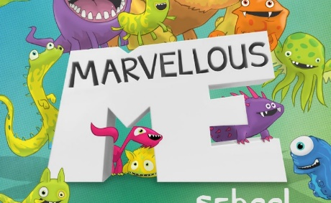  Marvellous Me  Traditional Fairy Tales |  | 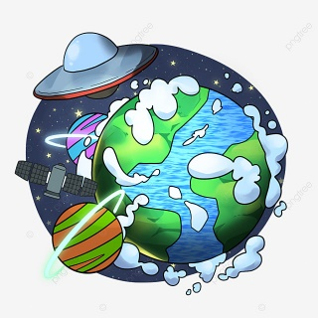  Space/The Earth |  |   The Living World  Pirates and The Living World
Core texts | Core nursery rhymes | Core texts | Core nursery rhymes | Core texts | Core nursery rhymes
My Hair  The Proudest Blue  All are welcome  Goodnight Moon  Handa’s Surprise  Funny Bones  After the Storm  We’re Going On A Bear Hunt  Mr Gumpy’s Outing  Rosie’s Walk  SHHH  I Can Read With My Eyes Shut | -5 Currant buns in baker’s shop  -Head, shoulders, knees and toes  -I’ve got a body, a very busy body  -Fingers, thumbs and toes  -Miss Polly had a dolly | Laura’s Star  Book of Traditional tales with Gender changed  CECE loves Science  Sasha Visits Beijing  The story of snow  Anno’s counting book  Pairs! In the garden  How do Dinosaurs count?  Farmer Duck  Owl Babies  Six Dinner Sid  The Napping House  Mouse Shapes  Mae Jemison: A Kid's Book About Reaching Your Dreams  Zaha Hadid – Little People, Big Dreams  The Girl Who Thought in Pictures Temple Grandin  National Geographic Little Kids First Big Book of Space  Little Kids First Big Book Of The World (National Geographic)  Greta Thunberg – Little People, Big Dreams  Spring, Lego Construction books – box set  Bees –and Lifecycle books  Poetry  I Wish I Had Duck Feet – Dr Seuss  Yert the Turtle | Poetry:  ICE!  The Pancake  There Was An Old Lady  Don’t Cry Caterpillar  The Tadpole  Know 5 nursery rhymes  I’m a little tea pot  This Old man  Five little speckle frogs  Five currant buns  Dr Foster went to Gloucester  Hey Diddle Diddle, Twinkle twinkle, 5 little men | The Bad Tempered Ladybird  The Very Busy Spider  Superworm  What the Ladybird Heard  Lifecycles of insects  Spiders  Bees  My Best Book of Creepy Crawlies  Worms  Learn about Lady birds  National Geographic – Ants kids  Stewart National Geographic - Bees  Titch  Jack and the Beanstalk  Ten seeds  The Tiny Seed  Jasper’s Beanstalk  Plants can’t sit still  Gigantic Turnip  Oliver’s Vegetables  Eddie’s Garden  Lola Plants a Garden  Flower Garden by  Green Green – Diverse  Growing/Plants  National Geographic Level 2 Seed a plant  National Geographic – In my Garden  What’s under Ground? Usbourne books  All about plants (Ways into Science) | Sing a song of Sixpence  Miss Polly had a dolly  I’m a little tea pot  This Old man  Five little speckle frogs  When I was one  Mary, Mary, quite contrary  Here we Go round the Mulberry Bush
AUTHORS | Martin Waddell  Eric Carle

