Nursery
Autumn 1: Marvellous Me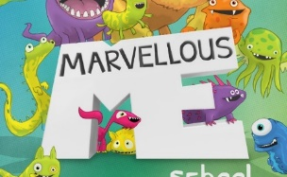  Autumn 2: Traditional Fairy Tales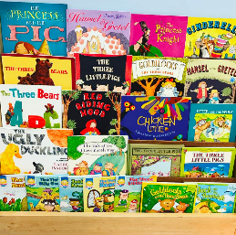 |  | Spring 1: Animals  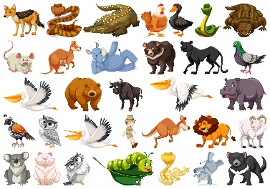  Spring 2: Growing  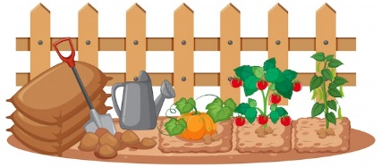 |  | Summer 1: Out & About  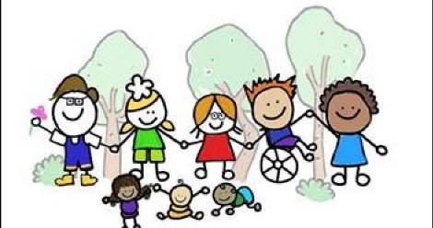  Summer 2: Superheroes  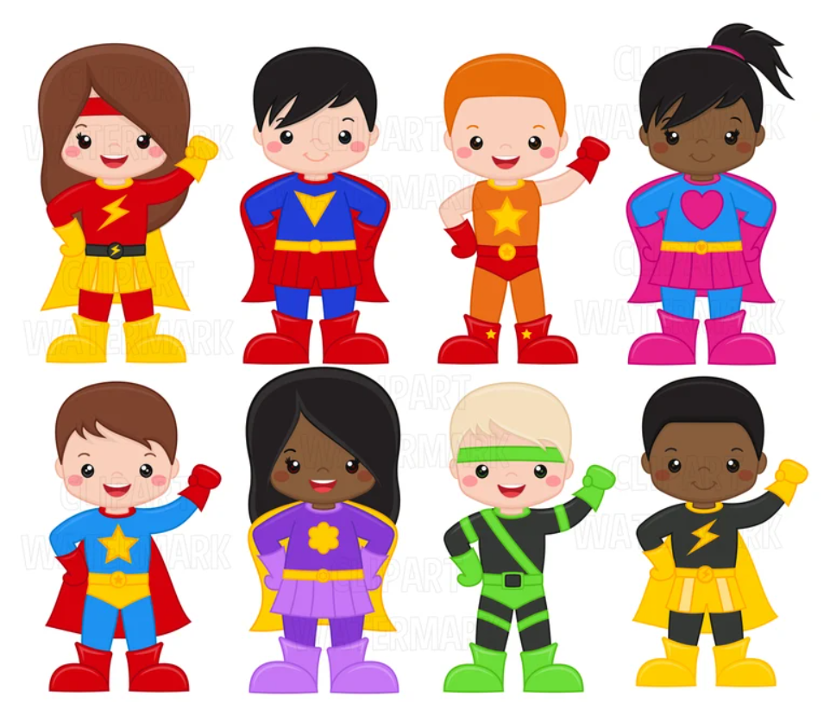
Core texts | Core nursery rhymes | Core texts | Core nursery rhymes | Core texts | Core nursery rhymes
-Lulu goes to Nursery  -Incredible me  -Things I like/Do  -My 5 senses  -Where are you from?  -Rainbow Fish  -Who’s in my Family?  -Owl Babies  -Goldilocks and the three bears  -Little Red Hen  - The Gingerbread Man  -The Three Little Pigs | - I have a body  -Twinkle, Twinkle Little Star  -Head, shoulders knees and toes  -The wheels on the bus | -and Tango makes three.  -Old McDonalds had a farm  -Dear Zoo  -Commotion in the Ocean  -Walking through the jungle  -Dinosaurs  -Life cycle of sunflowers  -The Enormous Turnip  -The very hungry Caterpillar by Eric Carle  -Our Garden  -Easter | -Old McDonald had a farm  -5 Little Ducks  -1, 2, 3, 4, 5, Once I got a fish alive  -5 Little Speckled Frogs  -Ring a Ring O’Roses | -Handa’s Surprise  -Train Ride  -I think I’ll go fly  -Space it’s the place  -Road Safety  -People that Help us  -Traction Man  -My Dad is Amazing  -Superworm  -Supertato  -Veggies Run  -Veggies Assemble | -Duke of York  -London Bridge is Falling Down  -Mary had a little lamb  -Hickory Dickory Dock  -Hokey Cokey

