South Lake Primary School Calculation Policy

This policy has been adapted from the White Rose
Calculation Policy, based on a Mastery approach.
The focus is on deepening conceptual understanding.
Problems are modelled with concrete materials, then
using pictorial representations of the materials,
leading to use of abstract symbols.

The indications of Year groups are for guidance only; teachers use their professional judgement as to whether consolidation of a certain concept is required before moving to the next.

Revised January 2020
Addition | Early Years-Year 1 | Concrete |  | Pictorial |  | Abstract
Addition | Early Years-Year 1 | Combining two parts to make a whole (variety of resources e.g. eggs, shells, teddy bears, cars). |  | Children to represent the cubes using dots or crosses. They could put each part on a part-whole model too. |  | 4 + 3 = 7 or 7 = 4 + 3  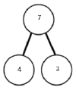  Four is a part, 3 is a part and the whole is seven.
Addition | Year 1 | Starting with the bigger number and counting on using number lines using cubes or Numicon.  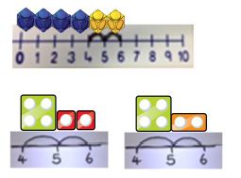 |  | A bar model which encourages the children to count on, rather than count all.  Start at the larger number and jump on in ones or one jump  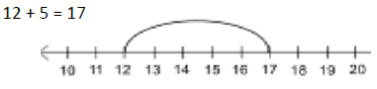 |  | The abstract number line:  What is 2 more than 4?  What is the sum of 2 and 4?  What is the total of 4 and 2?  4 + 2  Put the larger number in your head and count on the smaller number.
Addition | Year 1 | Regrouping to make 10; using ten frames and counters/cubes or using Numicon.  6 + 5  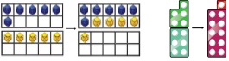 |  | Children to draw the ten frame and counters/cubes. |  | Children to develop an understanding of equality, eg  6 + = 11  6 + 5 = 5 +
Addition | Year 2  Year 2  Year 2 |   Adding 3 single digits  Combine to make 10 if possible; or bridge 10, then add the third digit. |  | Children regroup and draw representations  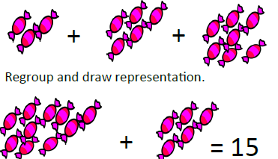 |  | Combine to make 10 if possible; or bridge 10, then add the third digit.  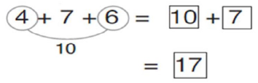
Addition | Year 2  Year 2  Year 2 | Using known facts  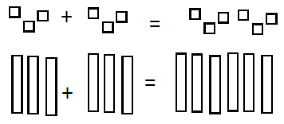 |  | Children draw representations of H,T,U  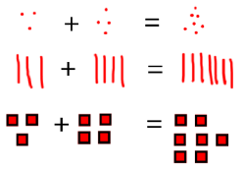 |  | I know 3+3 = 6  so 30 + 30 = 60  and 300 + 300 = 600
Addition | Year 2  Year 2  Year 2 | TU + U  Use dienes to continue to develop understanding of place value e.g. 41 + 8  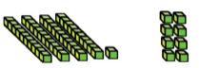  Initially not crossing 10.  Then moving on to regrouping (exchanging) when crossing 10 e.g. 26 + 5 |  | 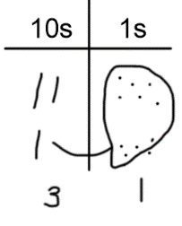  Children to represent the dienes e.g. lines for tens and dots for units.  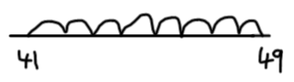 |  | 41 + 8 1 + 8 = 9  40 + 9 = 49  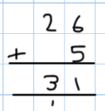
Addition | Year 2  Year 2  Year 2 |  |  |  |  | Look for ways to make 10.  36 + 25 = 30 +20 + 5 + 5 + 1  = 50 + 10 + 1  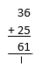  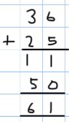  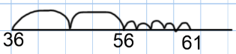  = 61  Formal methods:
  TU + TU
  Use dienes to continue to develop understanding of partitioning and place value e.g. 36 + 25
  Number lines may also be used.
  Children to represent the base 10 in a place value chart.
Addition | Year 3 |  |  | Children to represent the counters in a place value chart, circling when they make an exchange. |  |  | Written method
  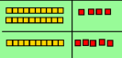
  HTU + TU, HTU + HTU
  Model with Dienes
  Move on to place value counters.
  When there are 10 ones in the 1s column, exchange for 1 ten; when there are 10 tens in the 10s column, exchange for 1 hundred.
Addition | Year 4 | ThHTU  Using place value counters up to thousands.  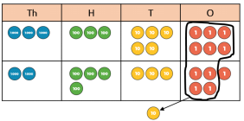 |  | As above, including thousands column |  |  | 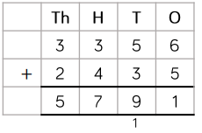Relate to money and measures problems
Addition | Year 5 | TTh Th H T U and U. t h  Working beyond 4 digits  Adding decimals with 2 decimal places  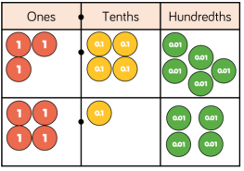 |  | 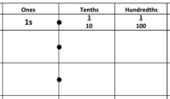  Children represent the counters in a decimal place value chart  1.23  0.31 |  |  | 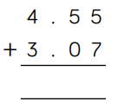
Addition | Year 6 | Add several numbers of increasing complexity  Using place value counters as Year 5  Adding money and measures, including decimals with different numbers of decimal places |  | As Year 5 |  |  |  | 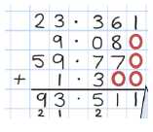  Use zero as a place holder
Conceptual variation; different ways to ask children to solve 21 + 34

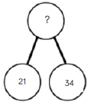 |  |  | Word problems:  In year 3, there are 21 children and in year 4, there are 34 children.  How many children in total?  21 + 34 = 55. Prove it |  | 21 + 34 = ___  ___ = 21 + 34  Calculate the sum of twenty-one and thirty-four.
  Missing digit problems:

Subtraction | Early Years-Year 1 | Concrete |  | Pictorial |  | Abstract
Subtraction | Early Years-Year 1 | Taking away ones  Physically taking away and removing objects from a whole (ten frames, Numicon, cubes and other items such as beanbags could be used).  4 – 3 = 1 |  | Children to draw the concrete resources they are using and cross out the correct amount. The bar model can also be used. |  | 4 - 3 = = 4 - 3
Subtraction | Year 1 |  |  | Children to represent what they see pictorially e.g. |  | Children to represent the calculation on a number line or number track and show their jumps. Begin to use an empty number line.  Mental:  Put 13 in your head, count back4. What number do you stop on?
  Counting back
  Using number lines or number tracks, children start with 6 and count back 2.
  6 – 2 = 4
Subtraction | Year 1 | Finding the difference  Using cubes, Numicon or Cuisenaire rods, other objects can also be used.  Calculate the difference between 8 and 5. |  | Children to draw the objects they have used or use a bar model to illustrate what they need to calculate.  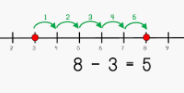  Count up on a number line |  | Find the difference between 8 and 5.  8 – 5, the difference is ____  Same difference:  9 – 6 = 8 – 5  Word problems:  Hannah has 12 sweets, her sister has 5. How many more does Hannah have?
Subtraction | Year 1 | Making 10 using ten frames  14 – 5 |  | Children present the ten frame pictorially and discuss what they did to make 10. |  | Children to show how they can make 10 by partitioning the subtrahend.  14 – 5 = 14 - 4 - 1  = 10 - 1  = 9  How many do we take off first to get to 10? How many are left to take off?
Subtraction | Year 2 | TU-U  Column method using dienes.  48 – 7  Initially not crossing 10.  Then moving on to regrouping (exchanging) when crossing 10 e.g. 62 - 5  Number lines may also be used. |  | Children to represent the base 10 pictorially, crossing out as they take away.  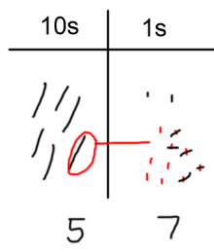 |  | Column method or children could count back 7.  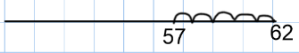  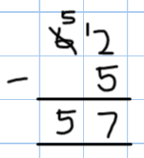  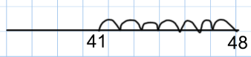
Subtraction | Year 2 | TU-TU  Column method using base 10 and having to exchange, using dienes.  41 – 26  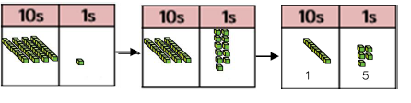  Number lines may also be used. |  | Represent the base 10 pictorially, remembering to show the exchange. |  |  | Formal column method. Children must understand that when they have exchanged the 10 they still have 41 because 41 = 30 + 11.  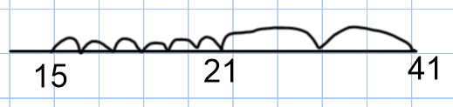
Subtraction | Year 3 | HTU-TU: no regrouping  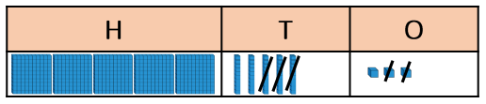  Model with Dienes |  | Draw representation as Year 2 |  |  | 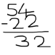
Subtraction | Year 3 | HTU-TU: with regrouping  Column method using place value counters to exchange.  234 – 88  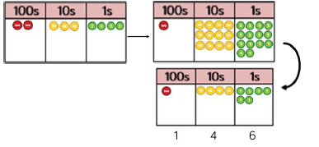 |  | Represent the place value counters pictorially; remembering to show what has been exchanged. |  |  | Formal column method. Children must understand what has happened when they have crossed out digits.
Subtraction | Year 4 | Subtracting tens and ones  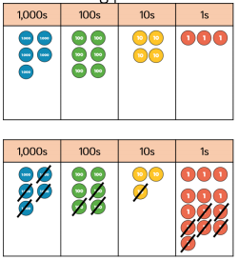  Up to 4 digits. |  | Represent the place value counters as above; remembering to show what has been exchanged. |  |  | 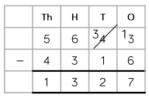
Subtraction | Year 5 | Subtracting numbers with at least 4 digits  Extending place value chart from Year 4  Introducing decimal subtraction with money and measures calculations. |  | Represent the place value counters as above; remembering to show what has been exchanged. |  |  | Line up the decimal point; use zero for place holder  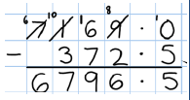
Subtraction | Year 6 | Subtracting increasingly complex numbers and decimals |  |  |  |  | 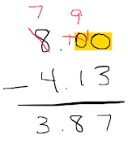  Use zero as a place holder
Conceptual variation; different ways to ask children to solve 391 - 186

 |  |  | Raj spent £391, Timmy spent £186.  How much more did Raj spend?  Calculate the difference between 391 and 186. |  | ___ = 391 – 186  What is 186 less than 391? |  |  | Missing digit calculations.

Multiplication |  | Concrete |  | Pictorial |  | Abstract
Multiplication | Year 1 | Repeated grouping/repeated addition  4 × 3  4 + 4 + 4  There are 4 in 3 equal groups. |  | Children to represent the practical resources in a picture and use a bar model. |  | Written calculations  4 × 3 = 12 12 = 4 x 3  4 + 4 + 4 = 12 12 = 4 + 4 + 4
Multiplication | Year 1 | Doubling  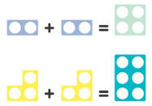  Use a variety of resources including cubes and Numicon  Double 4: |  | Children draw pictures of doubles  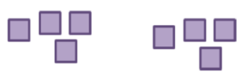 |  | 2 x 4 = 8
Multiplication | Year 1 | Number lines to show repeated groups-  4 x 3 |  | Represent this pictorially alongside a number line e.g. |  | Abstract number line showing three jumps of four.  4 x 3 = 12
Multiplication | Year 2 | Use arrays to illustrate commutativity Counters and other objects can also be used.  2 × 5 = 5 × 2 |  | Children to represent the arrays pictorially. |  | Children to be able to use an array to write a range of calculations e.g.  2 x 5 = 10 or 10 = 2 × 5  5 × 2 = 10 or 10 = 5 x 2  2 + 2 + 2 + 2 + 2 = 10  10 = 5 + 5
Multiplication | Year 2 | Doubling  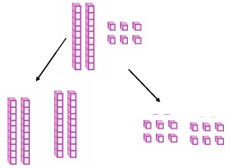  Use Dienes and place value counters  Double 26: |  | Children draw representations of materials |  | Doubling 2-digit numbers:  Partition and double each part, recombine  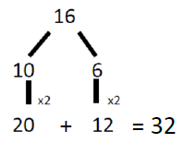
Multiplication | Year 2 | Counting in Multiples of 2, 3, 4, 5, 10  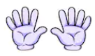  Groups of objects/fingers used for skip counting |  | Number lines, counting sticks, bar models  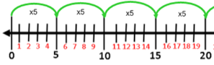  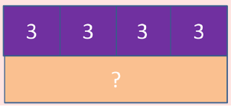 |  | Count in 2s etc verbally  Write sequences of multiples  0, 2, 4, 6, 8..  0, 5, 10, 15,…
Multiplication | Year 3 | U x TU: Partitioning  Partition to multiply using Numicon or dienes  4 × 15  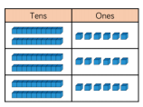  Relating to place value chart  3 x 26 |  | Children to represent the concrete manipulatives pictorially.  4 x 15 |  | Children to be encouraged to show the steps they have taken.  A number line can also be used
 | Year 4 | U x TU: Formal column method  Place value counters or dienes. No exchanging.  3 × 23 |  | Children to represent the counters pictorially. |  | Children to record what it is they are doing to show understanding.  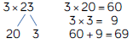
 | Year 4 | U x TU: Formal column method  Formal column method with place value counters. With an exchange, crossing 10.  6 x 23 |  | Children to represent the counters/base 10, pictorially e.g. the image below.  23 x 6: |  | Formal written method
Multiplication | Year 5 | Grid method  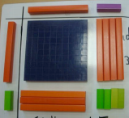  Place value counters or dienes, partitioning numbers, multiplying separate parts, then combining.  14 x 13 |  | 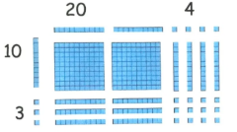  Representations of Dienes |  | 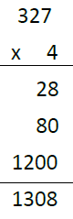  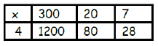  Recording grid, with addition alongside  Leading to compact method  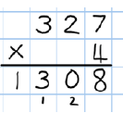
Multiplication | Year 5-6 | Column multiplication up to 4 digits x 2 digits and 3 digits x 3 digits  Children must be confident with the abstract calculations HTU x U and HTU x T  Concrete materials can still be used. |  | Pictorial representations as above |  | Formal written method
Multiplication | Year 6 | Multiplication of decimals |  |  |  | Formal written method  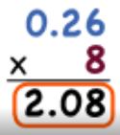  Ensure the answer has the same number of decimal places as the question
Conceptual variation; different ways to ask children to solve 6 × 23

 |  |  | Mai had to swim 23 lengths, 6 times a week.  How many lengths did she swim in one week?  With the counters, prove that  6 x 23 = 138 |  | Find the product of 6 and 23  6 × 23 =  __ = 6 × 23 | What is the calculation?  What is the product?

Division |  | Concrete |  | Pictorial |  | Abstract
Division | Year 1 |  | Division as Sharing  Using a range of objects.  6 ÷ 2 | Represent the sharing pictorially. |  | 6 ÷ 2 = 3  Children should also be encouraged to use their 2 times tables facts.
Division | Year 2 |  | Division as Grouping  Using objects, divide into equal groups  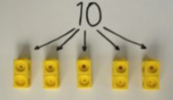 | 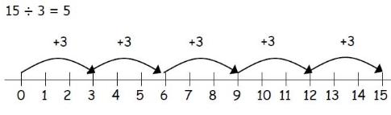  Using number lines and bar models  Split the whole into groups; how many will be in each group? |  | 20 ÷ 5 = 4  Divide 20 into 5 groups. How many are in each group?
Division |  |  | Repeated subtraction using Cuisenaire rods above a ruler. 6 ÷ 2 | Children to represent repeated subtraction pictorially. |  | Abstract number line to represent the equal groups that have been subtracted.
Division | Year 3 |  | Division with Arrays  Link division with multiplication by creating an array and finding the related number sentences  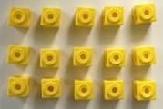 | Draw arrays and split into groups  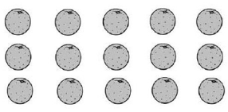  15 ÷ 5 = 3  15 ÷ 3 = 5 |  | Find the linking number sentences  15 ÷ 5 = 3  15 ÷ 3 = 5  5 x 3 = 15  3 x 5 = 15
Division |  |  | TU ÷ U with remainders  Using objects or lollipop sticks. Cuisenaire rods, above a ruler can also be used.  13 ÷ 4  Use of lollipop sticks to form wholes- squares are made because we are dividing by 4.  There are 3 whole squares, with 1 left over. | Children to represent the lollipop sticks pictorially.  There are 3 whole squares, with 1 left over.  Draw dots and group them, clearly showing the remainder  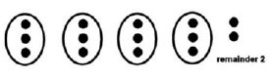 |  | Written: 13 ÷ 4 – 3 remainder 1  Children should be encouraged to use their times table facts; they could also represent repeated addition on a number line.  ‘3 groups of 4, with 1 left over’
Division |  |  | TU ÷ U  Sharing using place value counters. 42 ÷ 3 = 14  Repeat with remainders e.g. 61 ÷ 5 = | Children to represent the place value counters pictorially.  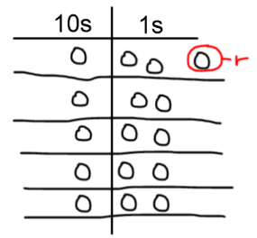 |  | Record in short division ‘bus stop’ format  61 ÷ 5  1 2 r 1  5 6 1
Division | Year 4-5 |  | HTU ÷ U  Short division using place value counters to group.  615 ÷ 5  1. Make 615 with place value counters.  2. How many groups of 5 hundreds can you make with 6 hundred counters?  3. Exchange 1 hundred for 10 tens.  4. How many groups of 5 tens can you make with 11 ten counters?  5. Exchange 1 ten for 10 ones.  6. How many groups of 5 ones can you make with 15 ones?  Repeat with remainders e.g. 643 ÷ 5 =  Year 5 extend to ThHTU ÷ U | Represent the place value counters pictorially. |  | Children to write the calculation using the short division scaffold.  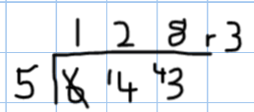
Division | Year 6 |  | HTU ÷ TU Long division  Using place value counters  2544 ÷ 12  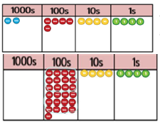  We can’t group 2 thousands into groups of 12, so we exchange them for 20 hundred counters  2 groups of 12, which leaves 1 hundred. We exchange this for 10 ten counters  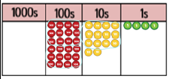  1 group of 12 in the tens column leaves 2 tens. We exchange them for 20 ones  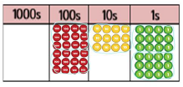  Group the 24 ones into 2 groups of 12, with noremainder |  | 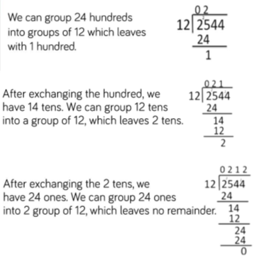

Conceptual variation; different ways to ask children to solve 615÷ 5
Using the part whole model below, how can you divide 615 by 5 without using short division? | I have £615 and share it equally between 5 bank accounts. How much will be in each account?  615 pupils need to be put into 5 groups. How many will be in each group? | 615 ÷ 5 =  ___= 615 ÷ 5 | What is the calculation?  What is the answer?

