The Explorer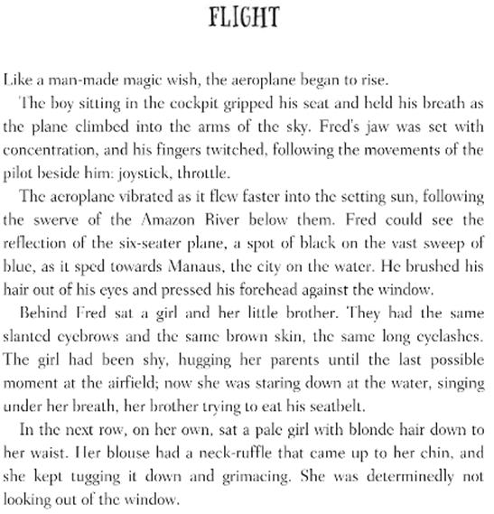
V - Find 3 verbs which describe how the plane is behaving.
I - How does ‘She was determinedly not looking out of the window’ suggest how the girl feels?
P - Why do you think the people are on the plane?
E - What evidence is there to suggest that the plane is flying low?
R - Find an example of alliteration, and an example of the power of three (three things in a list that are similar).
S - Summarise what the atmosphere is like on the plane.

