Year 5 - Week beginning 29th June
Reading Tasks
Read a book of your own choice for 20 minutes a day.

Reading Comprehension:
Playground Equipment Letter
The Hound of the Baskervilles

When answering Reading Comprehension questions, remember to give a full answer using APE (Answer the question, Prove your answer with evidence, Explain how your evidence backs up your answer). For example:
P
A
The students have considered all the options for the playground. In the text, it says that they took the time to look at catalogues of play equipment which shows that they have been thorough in their research.
E

Writing Tasks
Monday

Look at this picture. What does it make you think? How does it make you feel?
Annotate round the pictures all the adjectives, expanded noun phrases, similes and metaphors you can think of which would be used in a description of this place. You should be able to think of a lot!

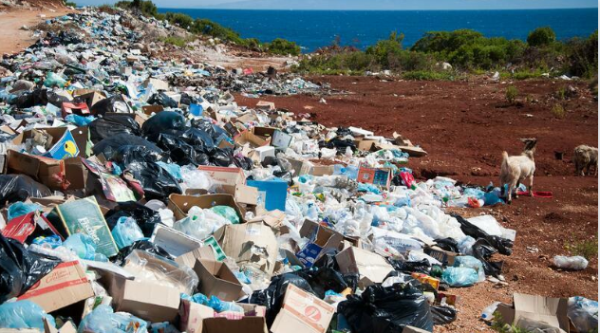

Tuesday

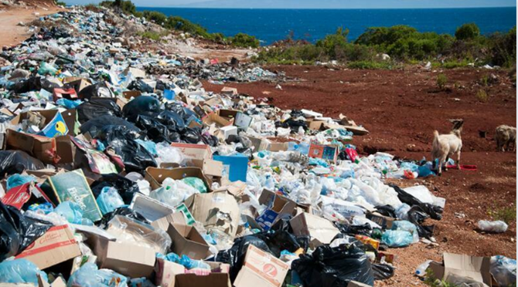

Use some of the ideas you had yesterday to describe this place – you should write at least 150 words.
A successful description will mean that you can tick off all the items in the list below:
- All senses used – smell, sound, sight, touch, taste
- Expanded noun phrases – e.g.
- Similes and metaphors are included for effect – e.g. There is a dreadful smell everywhere, like rotten eggs. (simile) The plastic is a pulsating carpet, covering the beach. (metaphor)
- Prepositions indicate where things are – under, into, behind, between, above etc
- Sentences are started in different ways
- Relative clauses add information – e.g. Piles of filthy boxes, which have started to rot and spew their contents onto the beach, litter the once pure sand.
- Powerful vocabulary helps the reader picture the scene - e.g. Mountains of filthy boxes, which have started to rot and spew their contents onto the beach, litter the once pure sand.
- Personification used to create effect –eg the plastic waste strangles the shore, tightening its grip with every new tide.

Wednesday
The pollution of the world with plastics is a growing problem in the world today. What do you know about it? Talk to an adult to find out more, or go online to find out what is happening. You could look at https://www.natgeokids.com/uk/kids-club/cool-kids/general-kids-club/plastic-pollution/ and https://www.youtube.com/watch?v=xGfIsMMTbL4 to remind yourself of why it is important.
Make a poster which shows the dangers of plastic pollution and suggests ways we can reduce it.

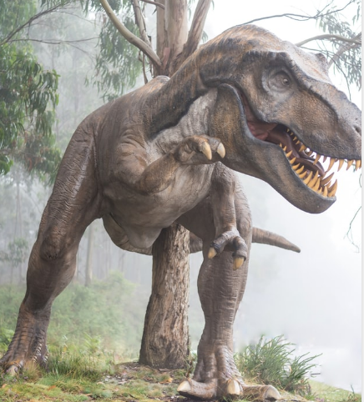
Thursday
Dinosaurs are already extinct – plastic didn’t kill them; it is likely that the changing climate did.
Find out about this dinosaur or another of your choice. Then write some sentences which must include relative clauses about your chosen dinosaur.

Sentence challenge
Relative clauses
Relative clauses begin with relative pronouns:

- who
- which
- where
- when
- whose
- that
For example:
- The mastodons, which were hunted by predatory species such as the saber-toothed cats, were gentle creatures.
- The Dodo, which was a flightless bird, enjoyed munching on seeds and fallen fruits.
Write your own sentences that include relative clauses. Choose relative pronouns from the list.
Friday
Read this non chronological report about Pandas. Use it to help you with the task itself!
GIANT PANDAS
Pandas are mammals, native to China where they are considered a national treasure. Being mammals, the females are able to produce milk to nurse their young. As with most mammals, Pandas have fur or hair on their bodies. The Giant Panda, which is known by other names including: parti-coloured bear, bamboo bear and the great panda, is easily distinguished from its distant cousin the red panda due to its large size and black-and-white coloured markings. It is thought that the bold colouring of the Giant Panda (Ailuropoda melanoleuca) may provide camouflage.
Habitats
In the wild, Giant Pandas are only found in the remote mountainous regions of central China, as this is where the cool bamboo forests that are perfect for the giant panda’s needs are located. Giant pandas make their dens from hollowed-out logs or stumps of conifer trees found within the forest.
In captivity, the Panda’s natural habitat is modelled using man-made structures and careful planting of bamboo, indigenous to China. However, the artificial version never quite matches up to the real environment in which Giant Pandas live in the wild.
Diet
Pandas are very fussy eaters. Giant pandas only eat bamboo - which is a type of grass that grows in the mountainous areas of China – whereas their cousin, the red panda has a varied diet consisting of nuts and seeds, Giant pandas need to eat for 12 hours a day in order to consume vast quantities of bamboo 28lbs/12.5 kg, thereby providing them with the necessary nutritients in order to survive. The giant panda’s stomach is ideal for digesting bamboo as the walls of the stomach are extra-muscular to digest the wood of the bamboo. The stomach is also covered inside with mucus that prevents it from being punctured by splinters.
Habits
Giant pandas are loners. They dislike being around other pandas so much that they have a heightened sense of smell that lets them know when another panda is nearby so it can be avoided. If another giant panda does get close, the two will end up swatting and growling at each other. Sometimes they will even bite each other.
Did you know?
- Pandas have an extra digit on their hands, which helps them to tear the bamboo.
- The Giant Panda does not hibernate but will shelter in caves or trees in very cold weather.

There are not many pandas left in the wild and they are a symbol for animal conservation all around the world. Many zoos and wildlife parks are trying to breed more pandas to save them from extinction.

Use the bullet pointed information to make your own non chronological report about another extinct animal : the sabre tooth tiger. Some of the information is useful, some not so useful.
There is a website you can use too : https://kidzfeed.com/saber-tooth-tiger-facts-for-kids-best-for-school-research-projects/
- In short, Sabre Tooth Tiger is prehistoric carnivorous mammal, with distinctive pair of long razor sharp canine teeth, that got extinct at the end of the Ice Age some 10,000 years ago.
- It is very popular among the prehistoric animals due to its fascinating looks and its elongated sword shaped canine teeth.
- It was found in North and South America.
- It existed between the Eocene and the Pleistocene period which ranges from 55 million years to 10,000 years ago.
- It was the primary predator in the woodlands and grasslands.
- Previous studies of fossils suggests that it became extinct mainly due to lack of food which was caused by the climate change. Climate change caused plants extinction which resulted in extinction of herbivores (animals that eat plants) and ultimately it caused Saber Tooth Tiger extinction as there were no more herbivores to hunt for food.
- Recent studies on fossils deny the above reason of extinction but do not provide any new theory.
The Sabre Tooth Tiger is also called the sabre-toothed lion or sabre toothed cats but in reality it is not a tiger or a lion or even close to the cats that we have today. It belongs to an extinct sub-family of the cat family (Felidae) which is called Nimravidae or the subfamily Machairodontinae.

- The Sabre Tooth Tiger has been named after its long and sharp Canines.
- Its two long canines could grow up to 20 cm or 8 inches, which helped in cutting and stabbing its preys.
- The lower canines were smaller in size and the molar teeth were smooth and resembled the modern day shearing blades.
- Its jaw could open up to an angle of 90 degrees in order to use the long teeth for hunting purposes. This gape is much larger than the modern cats.
- Its neck had strong muscles to bring down the heads of large preys.
- Its limbs were short but very well developed for hunting.
- The fully grown Sabre Tooth Tiger size was about that of a modern day African Lion (Panthera Leo).
- The smallest species, S. gracilis found in North America weighed 55 to 100 kg. And the largest species from South America, S. populator weighed 220 to 400 kg.
- The coat colour pattern of the Sabre Tooth Tiger is not known for sure.

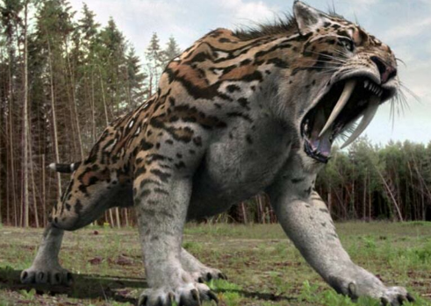

Make sure that you can tick all the Success Criteria!

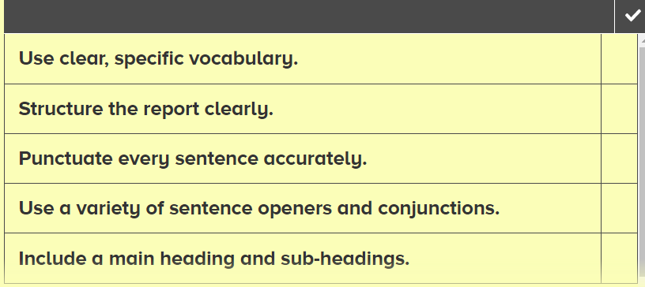
Foundation Subjects

RE: Sikhism

Watch the video showing the 5 Ks of Sikhism:
https://www.bbc.co.uk/teach/class-clips-video/religious-studies-ks2-five-ks-of-sikhism/znbhf4j

Create a poster to show the 5 Ks and what they mean.

Include some important information about each of the 5 Ks.
Think about how to make your poster eye-catching and interesting.

ORACY: Explain your poster to someone in your household. Try to speak clearly and fluently, delivering the information in an engaging way.

History: Henry VIII
Having looked at the Mary Rose ship last week, this week we will find out a little more about the king that commissioned the building of that ship, Henry VIII.

Have a look at: https://maryrose.org/henry-viii-the-tudor-story/
Also watch this Horrible Histories compilation: https://youtu.be/CceZIMnZnQs

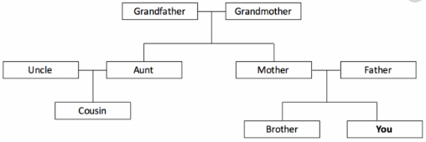
This is how a family tree usually looks:

Use this template to create a family tree which shows Henry VIII’s 6 wives and 3 children:
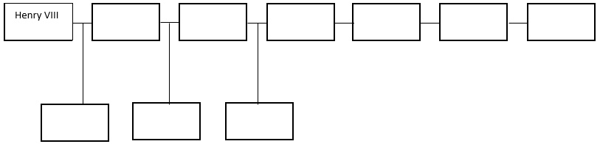

Can you add 2 or 3 paragraphs to share some additional information that you’ve learnt from watching the Horrible Histories programme and from reading about him using the links above.

The information is also included below in case you need it:
The Tudors
The Tudor family were the ruling House of England and Wales between 1485 and 1603. They came to power when Henry VII became king after his defeat of Richard III at the Battle of Bosworth Field in 1485.
The Tudor period really took off under the rule of Henry VII’s son, Henry VIII. Born in 1491, Henry became king after his father died in 1509, and he went on to become one of England’s most well-known rulers.
The Tudor Rose
The emblem of the Tudor family, the Tudor Rose, combines the white rose of York and the red rose of Lancaster, symbolising the union between those houses at the end of the Wars of the Roses. It is still used in English heraldry to this day, as well in more general use to represent England.
The six wives of Henry VIII
Henry VIII’s most famous for his six marriages;
Catherine of Aragon: 1509-1533 (mother of Mary I of England, divorced)
Anne Boleyn: 1533-1536 (mother of Elizabeth I of England, beheaded)
Jane Seymour: 1536-1537 (mother of Edward VI, died in childbirth)
Anne of Cleves: 1540 (divorced)
Catherine Howard: 1540-1542 (beheaded)
Catherine Parr: 1542-1547 (widowed)

The Church of England
It was partly Henry VIII’s desire to annul his first marriage that inspired his main impact on English history – The Reformation, where he broke away from the Roman Catholic Church and established himself as the Supreme Head of the Church of England, a title the British Monarch holds to this day. Henry VIII also began the Dissolution of the Monasteries, dismantling churches and monasteries to claim their assets for the royal treasury. Henry VIII changed the face of religion in England forever.

'Fit' for a king
Henry is also known for his girth, and is often shown as a large, rather gluttonous man. However, in his early years Henry was quite an athlete, taking part in sports such as archery, tennis, wrestling and jousting. Sadly, it was while jousting in 1536 that Henry VIII suffered a serious leg injury that prevented him from competing again, but the lavish lifestyle of the royal court meant that he began to get larger. Towards the end of his life, he weighed around 145kg (320lb), and needed a pulley system to get in and out of bed. The same jousting accident also caused a severe head injury, which appears to have affected his behaviour, making him paranoid and cruel. He died aged 55, on 28th January 1547.

Henry VIII's legacy
He was succeeded by his son, Edward VI, who was only 9 years old. A sickly child, he died aged 15 in 1553, and was succeeded by his older half-sister, Mary I, who ruled until 1558. In turn, she was succeeded by her younger half-sister, Elizabeth I, who ruled England until her death in 1603. As Elizabeth produced no heirs, the crown was passed to the House of Stuart, making James VI of Scotland James I of England and Wales. The reign of the Tudors was over, but their legacy lives on.

PE: Sport’s Day Events

Can you have a go at some of the Sport’s day events that we would usually be practising at this time of year?

You can choose from:

Throwing – use a balled-up piece of paper, a balled-up pair of socks or make a paper aeroplane. Set a target distance and see if you can throw accurately to that distance.

Running – Time how long it takes you to run a certain distance. Try hard to get a fast time. See if you can repeat the same distance in the same time. The more times you repeat this exercise the harder it will become because you’ll start to go slower and your tiredness will hamper your ability to judge your speed.

Triple Jump – (also known as the Hop, Skip and Jump) – Choose a ‘take off’ leg and mark a ‘start line’ for your jump. Take a run up towards your ‘start line’, when you reach the ‘start line’ take off from your ‘take off’ leg, land again on your ‘take off’ leg and spring into the air again, land on the other leg and spring into the air again, then land with both feet together. Measure the distance of your Triple Jump from your ‘start line’ to where you land with both feet together. Measure to the heel of your feet. This takes a lot of practise.

High Jump – Stand next to a wall. Stand with your feet together and jump up high with your arm held up and touch the highest brick that you can on the wall. See if you can improve the height with each jump.

If you want to try other activities, please do! We would love to see some photos of your efforts.

Geography – Mountains formation and climate:
Last week you created notes about:
Categories of mountains and Categories of mountain climate
Volcanic Bushland/Cultivated Zone
Dome Rain Forest Zone
Fold Heath/Moorland Zone
Block Alpine Desert Zone
Arctic Zone
In case you need it, the information that you used last week is included below again. ONLY PRINT THIS IF YOU MUST.
Using the notes that you made last week, create a leaflet about mountains:
You have a lot of information, so you need to decide what you would like to include in your leaflet. It could be only about types of mountains or only about mountain climates, or a mix of the most interesting information from both topics.
Remember, the information provided in leaflets is there to spark someone’s interest and to make them want to find out more. You are not writing a text book.

Fold your paper as shown.
Consider which side of your leaflet is the front cover and which side is the back cover.
Think about how to lay out the information in the most organised and eye-catching way.

CHALLENGE: Can you use COHESIVE DEVICES to link together sections of your Mountains Leaflet? For example:
As the magma pushes up, … Because the mountain is very large, … and so After that, when because First,
Text from the first video https://youtu.be/HVqfaUWurSs :
Defining what a mountain is can be tricky, but a good definition is, "any land mass higher and steeper than a hill."
Many geographers agree that mountains are a minimum of two thousand feet high, and have a slope that's greater than two degrees.
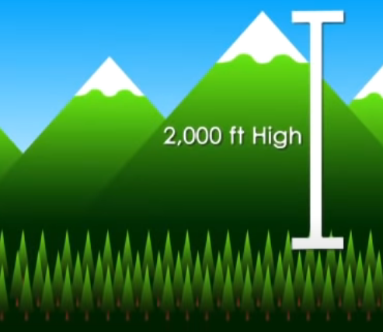
There are many types of mountains, and they are classified by how they are formed.
Volcanic and dome mountains are formed by the molten rock, or magma, found beneath the earth's crust. Volcanic mountains are made when erupting magma cools and hardens, forming a cone shape.
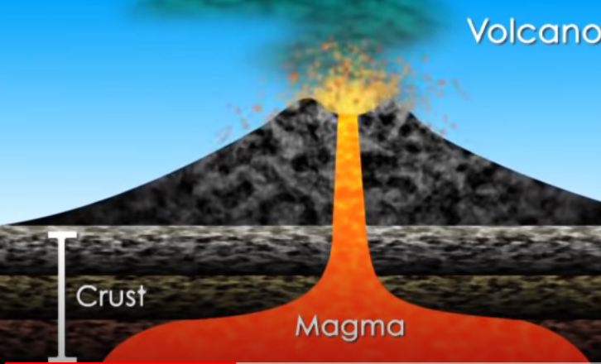
Dome mountains are made when magma causes the crust to bulge, and then subsides, leaving a rounded formation behind. Japan's Mount Fuji is a famous volcanic mountain, while the Adirondacks in the Eastern U.S. are well known dome mountains.
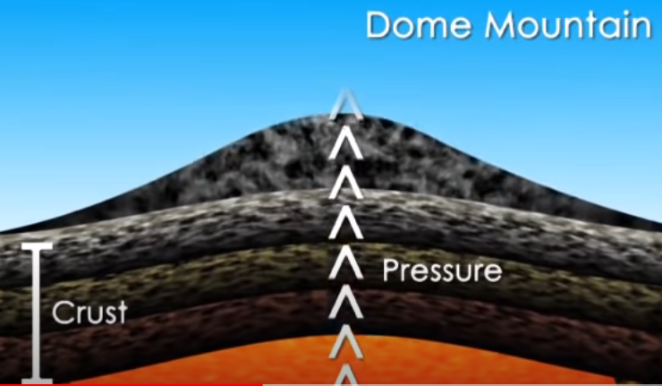
Fold mountains form when the plates that make up the earth's crust collide or pass over top of one another, causing the crust to wrinkle and fold. The Rocky Mountains in the North American west and Europe's Alps are fold mountains.
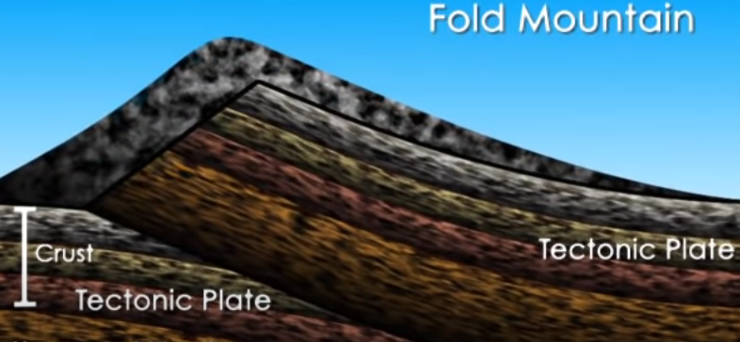
Block mountains are made when pressure on giant cracks in the earth's crust, or "faults," cause slabs of rock to tilt upward and sometimes stack on top of one another. America's Sierra Nevada Mountains are block mountains.
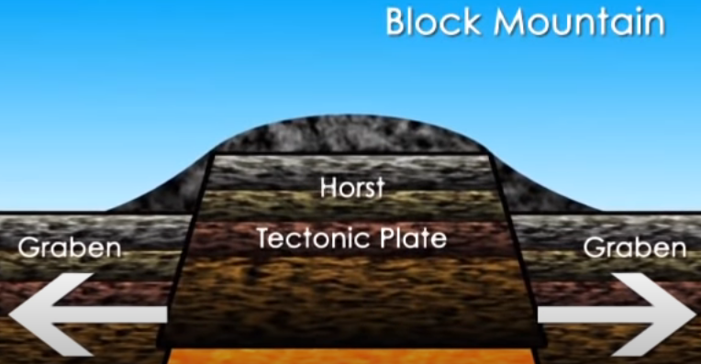

Kilimanjaro's Five Ecological Zones
Below are Mount Kilimanjaro's zones from the lowest to the highest altitude along with the average annual precipitation, zone characteristics, and links/feeds to the current weather in each particular zone.

Bushland/Cultivated Zone
Altitude: 2,600 to 6,000 ft (800 to 1,800 m)
Precipitation: 20 to 70 in (500 to 1,800 mm)

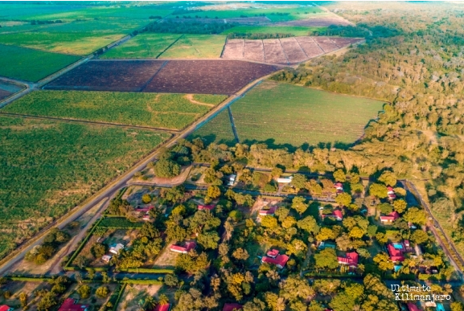
The lowest elevation climate zone is the bushland, resting a half mile or more above sea level. Cultivated land, grasslands and populated human settlements characterize this zone.
Natural bush, plains, and lowland forests once covered the region. However, because this area is rich with fertile volcanic soil, it makes an ideal land for agriculture, such as highly-prized coffee and tropical fruits. The grounds are irrigated by underground channels tunnelling through the earth from the lush rainforest nestled above.
Many of the local mountain guides hail from the nearby villages. Large wild animals are rarely seen here, having been eliminated by farmers, generations ago. However, small nocturnal mammals such as galagos and tree hyrax still thrive. Birds, such as speckled mousebirds and tropical boubou, are also are plentiful.
Rain Forest Zone
Altitude: 6,000 to 9,200 ft (1,800 to 2,800 m)
Precipitation: 79 to 40 in (2,000 to 1,000 mm)
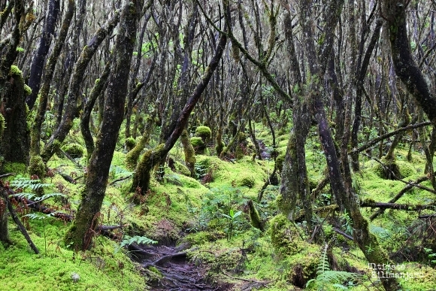
The rain forest is drenched by six to seven feet of rain per year and bursts with biodiversity. During the day, warm temperatures and high humidity characterize this densely forested climate zone. However, rainy nights can produce surprisingly low temperatures. Climbers definitely want to have their rain gear handy to protect themselves from the constant drizzle.
The rain forest presents the most abundant opportunities for viewing unique types of African flora and fauna: orchids, ferns, sycamore figs, olive trees, and palms dripping with hanging mosses. Camphorwood trees reach as high as 130 feet through the canopy grasping for sunlight. Blue and Colobus monkeys gallivant through the trees, loudly beckoning mates, and a vibrant cacophony of sounds emanate from the diverse population of birdlife.
Climbers approaching the summit from the Rongai, Lemosho, Shira or Northern Circuit routes may be lucky enough to spot elephant, buffalo, antelope and an occasional predator drifting through in search of a wayward meal.
Heath/Moorland Zone
Altitude: 9,200 to 13,200 ft (2,800 to 4,000 m)
Precipitation: 51 to 21 in (1,300 to 530 mm)
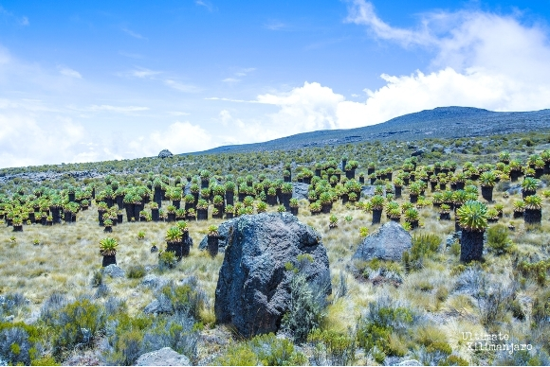
This semi-alpine zone is characterized by heath-like vegetation and abundant wild flowers. According to mountain medicine, the heath zone is in the "high altitude" region. There is decreased oxygen at this level.
The humidity and dense forest surroundings begin to give way to drier air and cooler temperatures. The flora thins into smaller shrubs like heather, and the presence of fauna becomes increasingly scarce. The most prominent flora are the unique and iconic Senecios (also known as groundsels) and Giant Lobelias. The Senecios, which translates from Latin to “old man,” have thick weathered stems topped with large, succulent rosettes. Lobelias resemble oddly-shaped palm trees with rosettes that close in the evenings to guard against the chilly night temperatures.
The most common birds seen in the heath zone are the easily recognizable black and white crows which forage around camp. Sometimes, large birds of prey such as the crowned eagle and lammergeyer soar overhead.

Alpine Desert Zone
Altitude: 13,200 to 16,500 ft (4,000 to 5,000 m)
Precipitation: 10 in (250 mm)
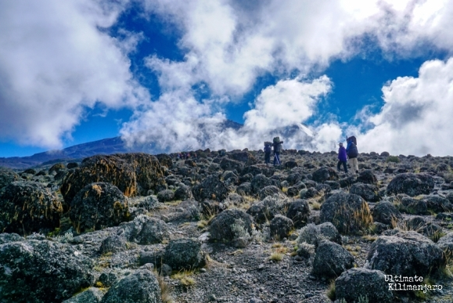
The alpine desert receives little water and so only light vegetation exists here. The temperature can reach over 100 degrees Fahrenheit during the day. The thin air and proximity to the equator result in very high levels of solar radiation. During the night, temperatures often plummet to well below freezing, leaving a dusting of morning frost.
This zone is in the “very high altitude" region of the mountain. This arid zone has thin soil that retains little water, making it inhospitable to most plant and animal species. Everlastings are one of the main plant species that can withstand such harsh conditions, as well as tussock grasses and varieties of moss.
A few of the animals that make appearances in the moorland will wander to these elevations, but the occurrences are very rare.

Arctic Zone
Altitude: 16,500+ ft (5,000+ m)
Precipitation: <4 in (100 mm)
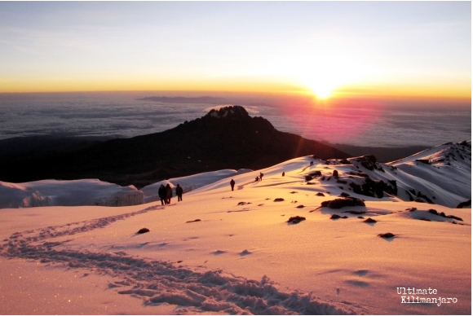
The final region of the climb up Kilimanjaro is the arctic zone. Finding a region like this in Africa’s equatorial belt is like finding a swath of rainforest in the middle of an Arctic glacier.

Characterized by ice and rock, there is virtually no plant or animal life at this altitude. Glacial silt covers the slopes that were once concealed by the now receding glaciers visible from Kilimanjaro’s crater rim. Nights are extremely cold and windy, and the day's unbuffered sun is powerful.

This zone is at "extreme altitude." Oxygen levels are roughly half of what they are at sea level.

