Year 5 - Week beginning 22nd June
Reading Tasks
Read a book of your own choice for 20 minutes a day.
Reading comprehensions can be found on the school website as usual. Try to answer all the questions in as much detail as you can. Answers can be found at the end of the comprehensions.
* Rainforest Creatures
* 25 years of the Internet
Writing Tasks
Monday

Here are some examples to start with:

What if dogs could fly?
What if everyone was red?
What if the sky fell down?

Write at least 10 ‘What if’ questions. Then choose one of them and write a paragraph about what would happen if…. Remember to make your writing as descriptive and entertaining as you can!

Tuesday
One of your questions from yesterday might have been ‘What if I was invisible?’

Imagine that you woke up one morning and found that you were completely invisible. What would you do?

Write a diary entry about that day.
Don’t forget that to write a successful diary you must follow the success criteria below.
- Past tense
- First person (me and I)
- Chronological order
- Personal thoughts and feelings included
- Only the main and important events are included
- Informal (as if you are talking to a friend) tone
- Clear start and finishing sentence
- Only one day written about

Wednesday

Watch ‘If I were in charge of the world’ by Judith Viorst
https://www.youtube.com/watch?v=9crFy0OFnzw or read the poem printed in Thursday’s lesson if you are unable to access the Internet. Listen to or read the poem at least twice. Do you agree with the poet’s ideas?
If you were in charge of the world – what would it be like?
Write a list of things that would happen (or not happen) if you were in charge of the world. Think about the things you would want to change – and how they should be changed. It can be as simple as banning a food, or as complex as having no more loneliness.
ORACY: When you have made you list (it should have lots of ideas not just two or three!) interview as many other people as you can and ask them what the world would be like if they were in charge.
List some of their ideas underneath yours. Does everyone agree? Are there any similar ideas?

Thursday
Read the poem below again
If I Were In Charge Of The World
If I were in charge of the world
I'd cancel oatmeal,
Monday mornings,
Allergy shots, and also Sara Steinberg.
If I were in charge of the world
There'd be brighter nights lights,
Healthier hamsters, and
Basketball baskets forty eight inches lower.
If I were in charge of the world
You wouldn't have lonely.
You wouldn't have clean.
You wouldn't have bedtimes.
Or "Don't punch your sister."
You wouldn't even have sisters.
If I were in charge of the world
A chocolate sundae with whipped cream and nuts would be a vegetable
All 007 movies would be U,
And a person who sometimes forgot to brush,
And sometimes forgot to flush,
Would still be allowed to be
In charge of the world.

How old do you think is the person who wrote this? What evidence is there? Highlight any alliteration and rhyming words.
Use the poem as a model for you to write your own poem. It should be called ‘If I were in charge of the word’ and be written in the same way as the one above – you will just need to change the ideas so that they are your own! Use the ideas you collected yesterday. Maybe you can even persuade your parents or siblings to write a verse and make it a family poem! ORACY TASK – perform your poem! Our challenge is for you to record it and send it to us!

Friday
Write a book review of one of the books you have read since March. You can use the template below, or make up one of your own.
It can be of any sort of book – non-fiction or fiction.

Foundation Subjects:
Foundation Subjects:
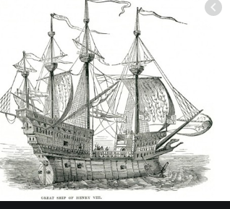
History:
Find out as much as you can about the Tudor ship called ‘Mary Rose’
Make a ‘lift the flap’ quiz with at least 10 questions about the Mary Rose. Don’t forget that you must include the answers under the flaps! Can you think of a really effective way to present your quiz?
You can use the following websites to help you:
https://maryrose.org/the-history-of-the-mary-rose/
http://www.primaryhomeworkhelp.co.uk/tudors/maryrose.htm
https://www.historyextra.com/period/tudor/mary-rose-facts-henry-viii-flagship-portsmouth-solent-when-sink/
Alternatively – choose some of the facts from here to make your quiz.
Here are some facts about the Mary Rose, the famous warship of the Tudor King Henry VIII.
- Construction of the Mary Rose began in 1510, and the ship was launched in 1511. It was built in Portsmouth.
- It was a ship built for war and it was armed with a variety of iron and cast bronze guns. The ship also carried a supply of pikes (very long spears) – to defend the ship against enemies trying to board it, longbows and a few matchlock muskets.
- Another large warship was built at the same time as the Mary Rose. This ship was called the Peter Pomegranate, probably named in honour of St Peter and Catherine of Aragon (the pomegranate was part of her coat of arms).
- Many people believe that the Mary Rose was named in honour of Henry VIII’s sister, Mary Tudor. This idea has been questioned by some historians. They think it is more likely that the Mary Rose was named in honour of the Virgin Mary and Henry VIII himself (the rose being the Tudor symbol).
- In peace time it is thought that the Mary Rose was crewed by less than 20 people. In times of war, however, the number of people on board would rise to 400 or more (sailors, soldiers, trumpeters and staff).
- The Mary Rose first experienced battle in 1512 against the French. In 1522 the ship was used to escort troops.
- The Mary Rose led the attack on the French fleet (who were intending to land troops to invade England) in the Battle of the Solent on 19th July 1545. Something happened to the Mary Rose when it engaged the French ships in combat. The ship began to take on water and it quickly started to sink. Over 90% of its crew lost their lives.
- It is thought that the cause of the Mary Rose’s sinking wasn’t any actions by the enemy, but rather a freakishly strong wind combined with the ship making a sharp turn at just the wrong moment. This lead to the gun ports on the main deck dipping underwater, and the ship taking on massive quantities of water.
- The Tudors tried to salvage the Mary Rose a few days after it was sunk. they were only successful in recovering some guns and rigging. Other attempts were made in 1547 and 1549.
- In 1836 a group of fisherman in the Solent rediscovered the Mary Rose after their nets got snagged on some timbers sticking out of the seabed. Henry Abbinett, a local diver, became the first person in nearly three hundred years to see the Mary Rose, when he dived to inspect the wreck.
- In 1971 the exact location of the wreck of the Mary Rose had been pinpointed. Excavation work started in 1978 and the ship was fully recovered and raised from the seabed on 11th October 1982.
- There were many finds from the wreck of the Mary Rose. These included: over 20,000 pieces of timber, casks for food and drink storage, woodworking tools, cannons, weapons, musical instruments, navigational equipment, surgeon’s tools and much more.
- The timbers of the Mary Rose have been exposed to a high-tech conservation process. Drying waterlogged wood without damaging it and destroying its form is really hard and time-consuming. The last phase of the conservation programme takes place in 2015.

ORACY Challenge: become an expert on the Mary Rose. Ask someone else to ask you the quiz questions and see if you can remember the answers! No cheating!

Art:
Watch the lesson on https://www.youtube.com/watch?v=D4hqKPX6d68
Follow the instructions and create your own pointillism picture.
Draw round your hand and colour it in
Use cotton buds only to make each small dot of colour
Be creative with blending the colour of dots to give the impression of the leaves!
Take a photo of your work and send it to us at school!

Music – Your favourite song.
Last week, you were challenged to create a dance for your favourite song. The week before that, you created a picture to show how you feel about your favourite song.
This week, we would like you to explain why you like your favourite song:
Write a paragraph that explains your feelings. You can consider some of the following questions when writing your paragraph:
How does it make you feel? Do you like the rhythm? Are the lyrics special in any way? Does the song remind you of someone, of something or of a particular place? What images does the song conjure in your mind? Do you particularly like singing this song? Do you like the band or the singer more than the actual song? Does the song make you dance? Have you enjoyed listening to this song with someone else? What makes your favourite song special to you?
Make sure that your paragraph includes all the information I need to know so that I understand what you’re talking about. So, you must include the song name and full sentences (not just answers to the above questions).
Ensure you start all your sentences with a capital letter and end all sentences with an appropriate piece of ending punctuation ( . ! ? ).
This is a bad example:
I like it because it makes me feel happy and the drums are good. No, the lyrics are not special. My dad, because it was on the radio. I think of chocolate which is weird. Yes, I like singing it. I like the singers and the song and it makes me move my shoulders. Not particularly with someone else. It’s good.
This is a good example:
My favourite song is Can’t hurry love, by Phil Collins. It’s quite an old song which used to be on the radio when I was a child so it reminds me of both my dad and of eating breakfast in the dark during the winter. I love the rhythm, which is offbeat and means that I just cannot resist the urge to sing and move. I like the lyrics but they aren’t particularly special to me; the lyrics do communicate a good message, though. This song never fails to make me feel happy because it’s such an upbeat tune! There aren’t many songs where people like both versions but I also really love the version by Diana Ross. I think you should give it a listen: I bet it makes you bop along!

Geography – Mountains formation and climate:
- Watch these two videos about how mountains are formed and about the plates in the Earth:
First: https://youtu.be/HVqfaUWurSs what is a mountain? (see the text below if you can’t watch this)
Then: https://youtu.be/Fd_XqYE2BWY where do mountains come from?
- Now have a look at this website to find out about the 5 mountain climates on Kilimanjaro in Tanzania (or read the same text below if you don’t have access to the internet):
https://www.ultimatekilimanjaro.com/mountain.htm
- Split your page into 2 columns, like this:

- Give your two columns these headers:
Categories of mountains Categories of mountain climate

- In each column you are going to make a note of the information you have learnt.
To help you, you can use these subheadings:
The subheading for the categories of mountains are: The subheadings for the categories of mountain climate on Kilimanjaro are:
Volcanic Bushland/Cultivated Zone
Dome Rain Forest Zone
Fold Heath/Moorland Zone
Block Alpine Desert Zone
Arctic Zone

For each category, try to note down as much information as possible. Use bullet points for your ideas and facts.
Next week, you will be making a leaflet, so a good plan now will help you next week.

Text from the first video:
Defining what a mountain is can be tricky, but a good definition is, "any land mass higher and steeper than a hill."
Many geographers agree that mountains are a minimum of two thousand feet high, and have a slope that's greater than two degrees.
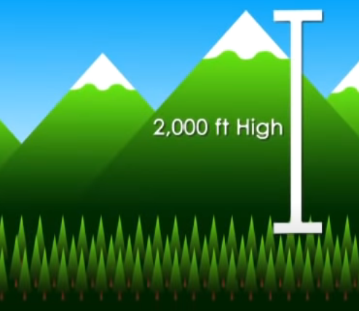
There are many types of mountains, and they are classified by how they are formed.
Volcanic and dome mountains are formed by the molten rock, or magma, found beneath the earth's crust. Volcanic mountains are made when erupting magma cools and hardens, forming a cone shape.
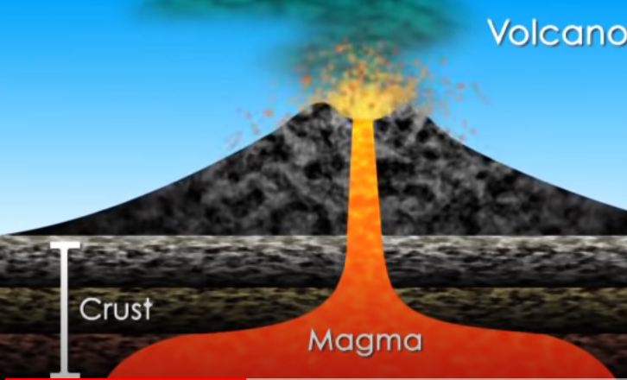
Dome mountains are made when magma causes the crust to bulge, and then subsides, leaving a rounded formation behind. Japan's Mount Fuji is a famous volcanic mountain, while the Adirondacks in the Eastern U.S. are well known dome mountains.
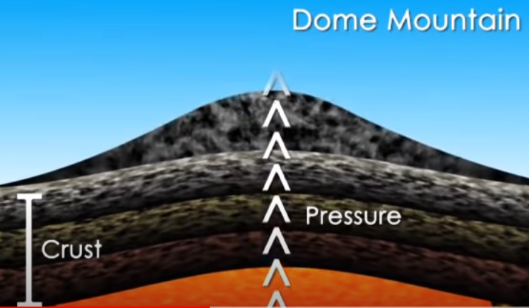
Fold mountains form when the plates that make up the earth's crust collide or pass over top of one another, causing the crust to wrinkle and fold. The Rocky Mountains in the North American west and Europe's Alps are fold mountains.
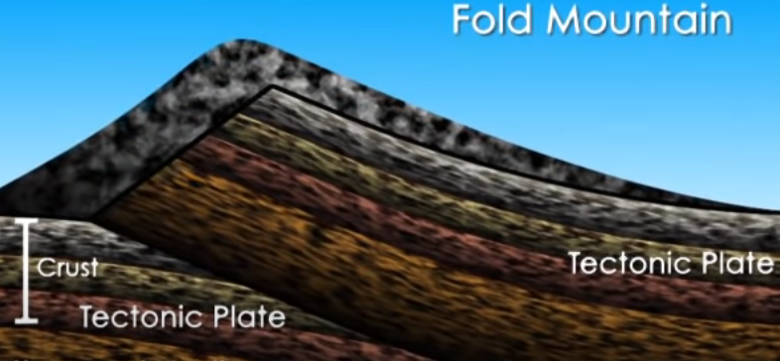
Block mountains are made when pressure on giant cracks in the earth's crust, or "faults," cause slabs of rock to tilt upward and sometimes stack on top of one another. America's Sierra Nevada Mountains are block mountains.
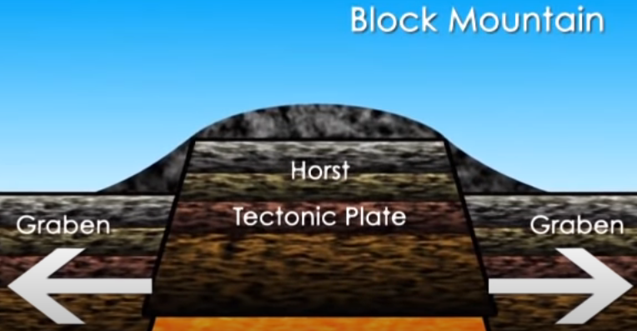

Kilimanjaro's Five Ecological Zones
Below are Mount Kilimanjaro's zones from the lowest to the highest altitude along with the average annual precipitation, zone characteristics, and links/feeds to the current weather in each particular zone.

Bushland/Cultivated Zone
Altitude: 2,600 to 6,000 ft (800 to 1,800 m)
Precipitation: 20 to 70 in (500 to 1,800 mm)

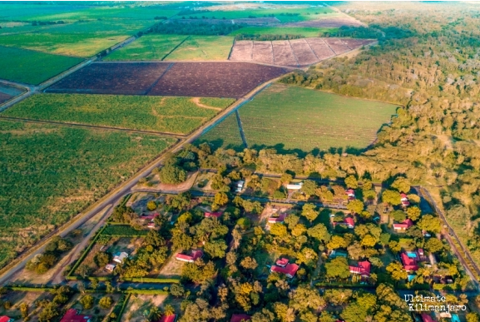
The lowest elevation climate zone is the bushland, resting a half mile or more above sea level. Cultivated land, grasslands and populated human settlements characterize this zone.
Natural bush, plains, and lowland forests once covered the region. However, because this area is rich with fertile volcanic soil, it makes an ideal land for agriculture, such as highly-prized coffee and tropical fruits. The grounds are irrigated by underground channels tunnelling through the earth from the lush rainforest nestled above.
Many of the local mountain guides hail from the nearby villages. Large wild animals are rarely seen here, having been eliminated by farmers, generations ago. However, small nocturnal mammals such as galagos and tree hyrax still thrive. Birds, such as speckled mousebirds and tropical boubou, are also are plentiful.
Rain Forest Zone
Altitude: 6,000 to 9,200 ft (1,800 to 2,800 m)
Precipitation: 79 to 40 in (2,000 to 1,000 mm)
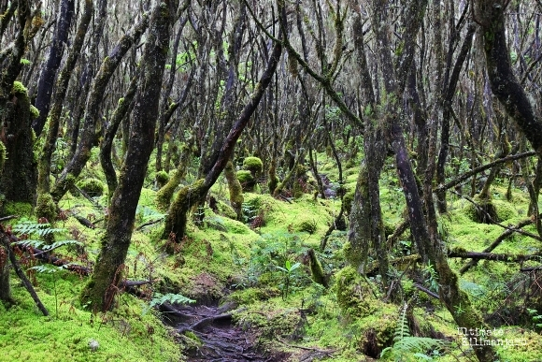
The rain forest is drenched by six to seven feet of rain per year and bursts with biodiversity. During the day, warm temperatures and high humidity characterize this densely forested climate zone. However, rainy nights can produce surprisingly low temperatures. Climbers definitely want to have their rain gear handy to protect themselves from the constant drizzle.
The rain forest presents the most abundant opportunities for viewing unique types of African flora and fauna: orchids, ferns, sycamore figs, olive trees, and palms dripping with hanging mosses. Camphorwood trees reach as high as 130 feet through the canopy grasping for sunlight. Blue and Colobus monkeys gallivant through the trees, loudly beckoning mates, and a vibrant cacophony of sounds emanate from the diverse population of birdlife.
Climbers approaching the summit from the Rongai, Lemosho, Shira or Northern Circuit routes may be lucky enough to spot elephant, buffalo, antelope and an occasional predator drifting through in search of a wayward meal.
Heath/Moorland Zone
Altitude: 9,200 to 13,200 ft (2,800 to 4,000 m)
Precipitation: 51 to 21 in (1,300 to 530 mm)
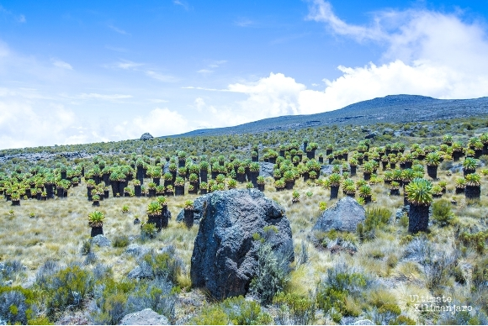
This semi-alpine zone is characterized by heath-like vegetation and abundant wild flowers. According to mountain medicine, the heath zone is in the "high altitude" region. There is decreased oxygen at this level.
The humidity and dense forest surroundings begin to give way to drier air and cooler temperatures. The flora thins into smaller shrubs like heather, and the presence of fauna becomes increasingly scarce. The most prominent flora are the unique and iconic Senecios (also known as groundsels) and Giant Lobelias. The Senecios, which translates from Latin to “old man,” have thick weathered stems topped with large, succulent rosettes. Lobelias resemble oddly-shaped palm trees with rosettes that close in the evenings to guard against the chilly night temperatures.
The most common birds seen in the heath zone are the easily recognizable black and white crows which forage around camp. Sometimes, large birds of prey such as the crowned eagle and lammergeyer soar overhead.

Alpine Desert Zone
Altitude: 13,200 to 16,500 ft (4,000 to 5,000 m)
Precipitation: 10 in (250 mm)
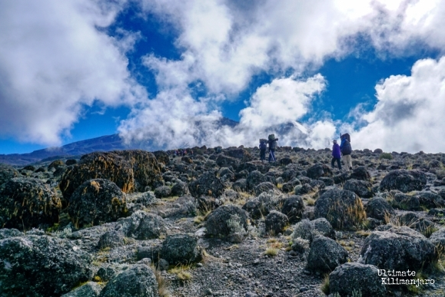
The alpine desert receives little water and so only light vegetation exists here. The temperature can reach over 100 degrees Fahrenheit during the day. The thin air and proximity to the equator result in very high levels of solar radiation. During the night, temperatures often plummet to well below freezing, leaving a dusting of morning frost.
This zone is in the “very high altitude" region of the mountain. This arid zone has thin soil that retains little water, making it inhospitable to most plant and animal species. Everlastings are one of the main plant species that can withstand such harsh conditions, as well as tussock grasses and varieties of moss.
A few of the animals that make appearances in the moorland will wander to these elevations, but the occurrences are very rare.

Arctic Zone
Altitude: 16,500+ ft (5,000+ m)
Precipitation: <4 in (100 mm)
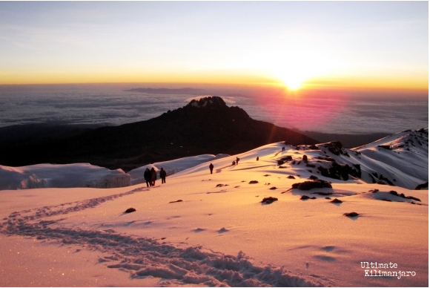
The final region of the climb up Kilimanjaro is the arctic zone. Finding a region like this in Africa’s equatorial belt is like finding a swath of rainforest in the middle of an Arctic glacier.

Characterized by ice and rock, there is virtually no plant or animal life at this altitude. Glacial silt covers the slopes that were once concealed by the now receding glaciers visible from Kilimanjaro’s crater rim. Nights are extremely cold and windy, and the day's unbuffered sun is powerful.

This zone is at "extreme altitude." Oxygen levels are roughly half of what they are at sea level.

