Year 5 - Week beginning 1st June
Reading Tasks
Two reading comprehensions (saved on Year 5 home learning page)
- William Wenton and the Secret Portal by Bobby Peers
- Spirit by Sally Christie
Writing Tasks
Monday 1st June 2020

from The Promise by Nicola Davies
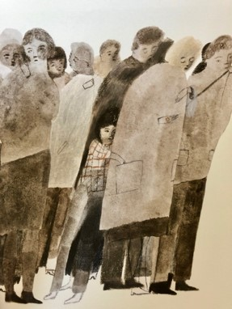

When I was young, I lived in a city that was mean and hard and ugly. Its streets were dry as dust, cracked by heat and cold, and never blessed with rain. A gritty, yellow wind blew constantly, scratching around the building like a hungry dog. Nothing grew. Everything was broken. No one ever smiled. The people had grown as mean and hard and ugly as their city, and I was mean and hard and ugly too.
I lived by stealing from those who had almost as little as I did. My heart was as shrivelled as the dead trees in the park.

- This is the start of a story. What do you think might happen in the rest of the book? Why do you think that?
- Underline any similes you can find. Are they effective? Why?
- Read the six memorable phrases taken from the text.
- The table below is all mixed up. Use lines to match the reasons to the phrases.

Memorable phrase |  | Reason it’s memorable
When I was young I lived in a city that was mean and hard and ugly. |  | This is an unusual adjective to have chosen. It makes the phrase vivid and memorable
A gritty, yellow wind blew constantly |  | Simile. The character’s inner condition is as desolate as the setting.
Scratching round the buildings like a hungry dog. |  | Three dramatic short sentences. Nothing, everything and no-one = hyperbole/possible exaggeration.
Nothing grew. Everything was broken. No one ever smiled. |  | Repetition giving emphasis and echoing: mean, hard, ugly.
The people had grown as mean and hard and ugly as their city, and I was mean and hard and ugly too. |  | A simile. The dog sounds wild and uncared for which fits the description of the city.
My heart was as shrivelled as the dead trees in the park. |  | The extra ‘and’ emphasises all three words in this list.

Now read part 2
Part 2
And then, one night, I met an old lady down a dark street. She was frail and alone, an easy victim. Her bag was fat and full, but when I tried to snatch it from her, she held on with the strength of heroes.
To and fro we pulled that bag until at last she said,
“If you promise to plant them, I’ll let go.” What did she mean? I didn’t know or care, I just wanted the bag, so said, “All right, I promise.” She loosened her grip at once and smiled at me. I ran off without a backward look, thinking of the food and money in her bag.

- Choose 3-5 memorable phrases of your own from this new section of the text.
- Draw an illustration to go with part 2. Put all your chosen memorable phrases round your illustration.

Oracy – show your answers to an adult and explain why you think they are memorable phrases. Why do you like them?

Tuesday 2nd June 2020
Re- read the extracts from yesterday.
- Find some powerful words or phrases and write an antonym (the word which means the opposite) for it. For example, ‘mean and hard and ugly’ – the antonyms here could change the phrase to ‘kind and soft and pretty’
- Use these antonyms to change the whole feeling of the story. Replace the adjectives with their antonyms and keep the rest of the text the same.
The first sentences might look like this (changed words are underlined) :
When I was old, I lived in a village that was kind and soft and pretty. Its streets were moist as moss, smoothed by coolness and warmth, and always blessed with sunshine.

ORACY – read your new version to an adult and compare it with the original story. Talk about the different feelings it creates. Discuss which sort of world you would prefer to live in and give reasons.

Wednesday 3rd June
- Use the PowerPoint on word classes or, if this is not possible, remind yourself using the chart underneath the text.
- Find examples of each class of word in Sea Myths and write them on the Classification Table.
- Choose one of the sea-creatures from Sea Myths. Research some more information about it and make a poster about all that you discover. Try to use illustrations and diagrams as well as normal text.
- ORACY TASK – share what you have found out with another person

Sea Myths
The Kraken
The kraken is a legendary monster. Scandinavian folktales told stories of this giant, terrifying creature who lived in the sea. Some stories told of the kraken pulling ships apart with its strong tentacles. Other myths were that it often caused dangerous whirlpools in the water which sunk ships fast. It is thought that the myths arose from sightings of giant squid and these terrified and inspired many stories.
Sirens
In Greek Mythology, the sirens were dangerous creatures, who lured unlucky sailors with their enchanting music and beautiful songs. The ships sailed into the rocks that surrounded the island and capsized. Sirens were half human and half bird. Originally, they could be men or women, but later stories described all sirens as women.
Merfolk
In folktales, a mermaid or merman is an aquatic creature with the upper body of a human and the lower body of a fish. They appeared first in stories in ancient Assyria but soon were told around the world. Some tales show merpeople as very kind and helpful towards sailors, while other stories link them to storms, floods and shipwrecks. Many people explain that belief in merpeople is because of manatees (or sea cows).
Selkies
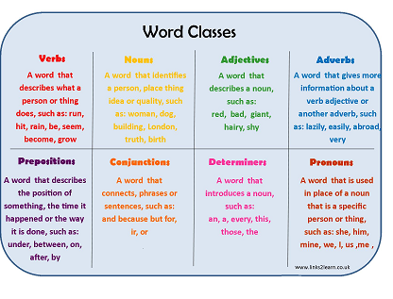
Selkies are found in folktales from the Northern Isles of Scotland. They are able to change from seal to human form by shedding their skins. In some stories they come to land and live as humans for many years before returning to the sea.
Classification Table

Nouns | Verbs
Adjectives | Adverbs
Prepositions | Determiners
Pronouns  including relative pronouns | Conjunctions

Thursday 4th June
Make up a mythical sea creature of your own. Draw a picture of the creature and then write a descriptive paragraph which could appear in a book about mythical creatures. You should give information about:
- appearance including any special features,
- where it lives
- what it likes to eat
- how it catches its prey
- what it’s behaviour is like
- Why people tell stories about it – what sort of stories are there?

Use the text from earlier in the week to help you. You should write a PARAGRAPH rather than write in bullet points. Remember to vary the way you start sentences and to try to group related information together – so all the information about appearance, for example, will be written together.

Friday 5th June
Oracy task.
Today you must prepare a mini lesson for another person in your house which teaches them about either word classes or mythical sea creatures. You will need to prepare any resources you need and can write notes for yourself so that you can be confident. Your lesson should last for around 5 minutes.

Foundation Subjects
- History - Look at the Map of Francis Drake’s Circumnavigation of the World and read about his journey below.
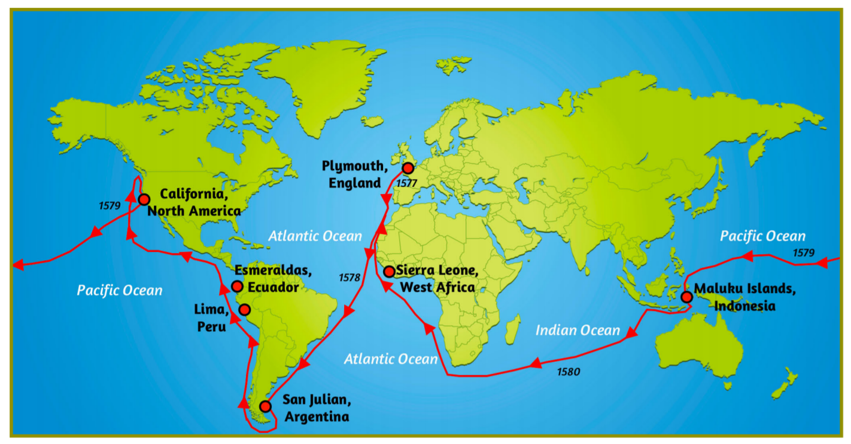
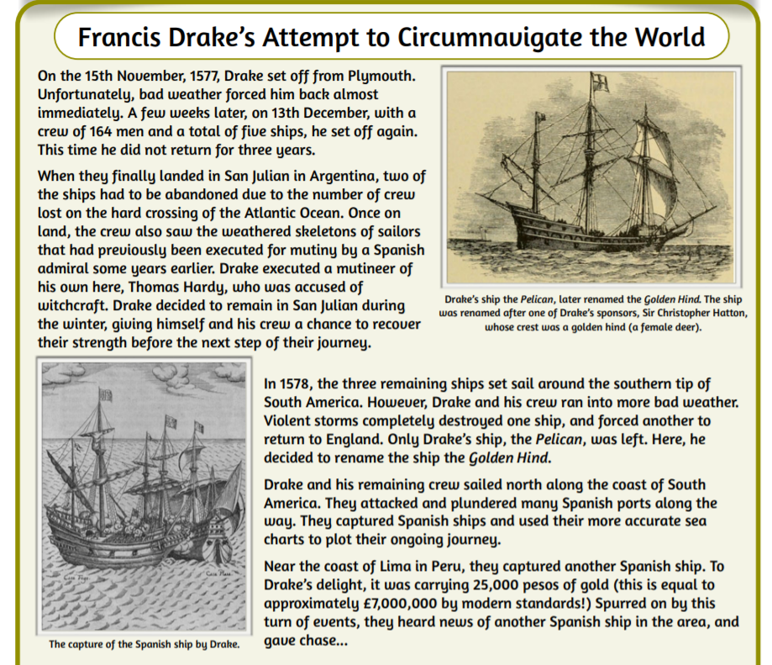
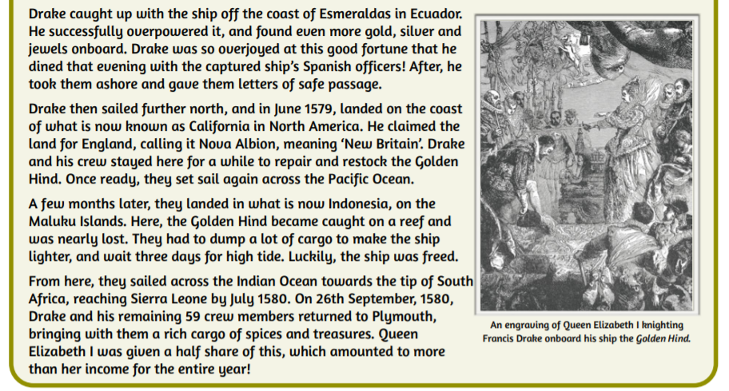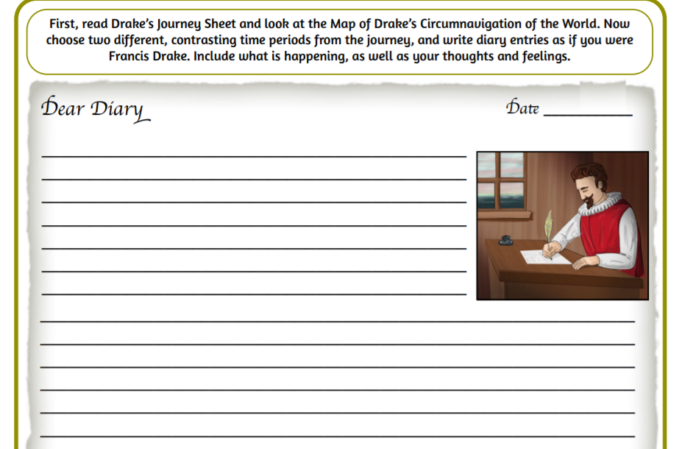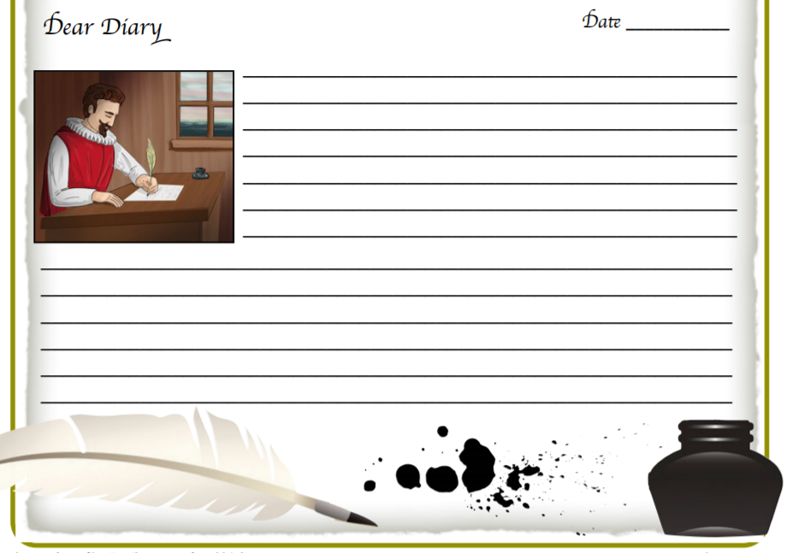

- Dance – watch this short video clip https://www.bbc.co.uk/bitesize/clips/zt4kjxs
Copy the steps then compose your own Tudor Dance based on this clip.
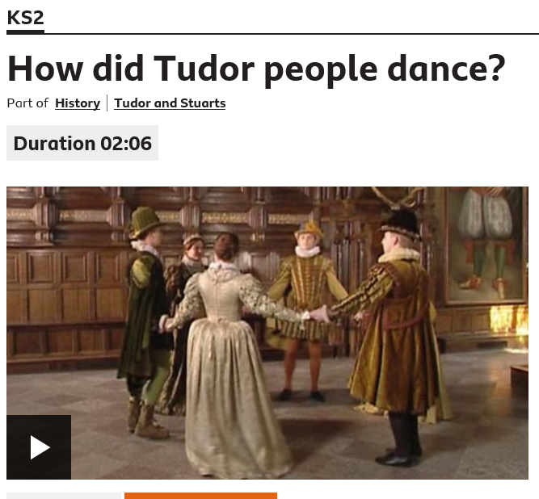

- Space-themed abstract art
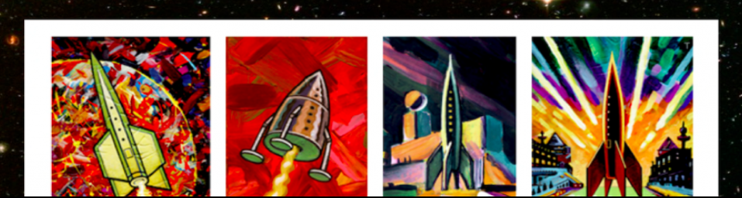
Abstract space artist Peter Thorpe is well known for painting rockets. Create a Peter Thorpe inspired rocket picture – you could use collage, chalk, pastels, paint or charcoal. You can find out more about Peter Thorpe here - http://www.peterthorpe.net/rocketsbio.html
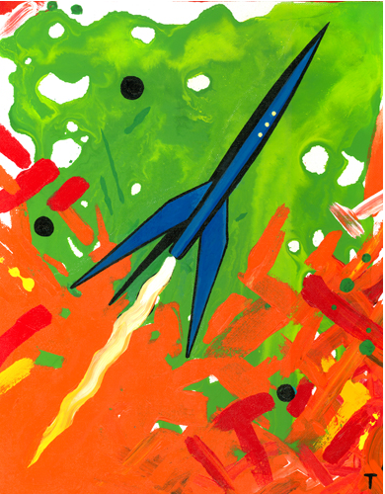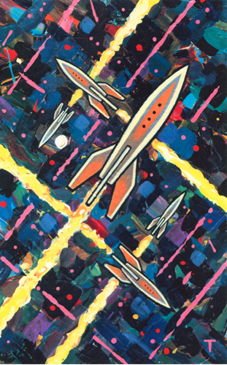

- PSHCE
Peter Thorpe said that the rocket paintings are his attempts to inspire people to explore space.
Who or what inspires you? Oracy task – share your thoughts with an adult at home.

