Year 5 - Week beginning 8th June
Reading Tasks
Read a book of your own choice for 20 minutes a day.
Reading comprehensions can be found on the school website as usual. Try to answer all the questions in as much detail as you can.
- The Umbrella
- When Did You Last See Your Father
Writing Tasks
Monday
https://www.youtube.com/watch?v=iYYRH4apXDo If you can, listen to’ Space Oddity’ by David Bowie. The song was written in 1969 which is the year that man first stepped onto the moon.

Space Oddity
Ground Control to Major Tom
Ground Control to Major Tom
Take your protein pills and put your helmet on
Ground Control to Major Tom (10, 9, 8, 7, 6)
Commencing countdown, engines on (5, 4, 3, 2)
Check ignition and may God's love be with you (1, Lift-off)
This is Ground Control to Major Tom
You've really made the grade
And the papers want to know whose shirts you wear
Now it's time to leave the capsule if you dare
This is Major Tom to Ground Control
I'm stepping through the door
And I'm floating in a most peculiar way
And the stars look very different today
For here
Am I sitting in a tin can
Far above the world
Planet Earth is blue
And there's nothing I can do
Though I'm past one hundred thousand miles
I'm feeling very still
And I think my spaceship knows which way to go
Tell my wife I love her very much
She knows….

Ground control to Major Tom,
Your circuit’s dead
There’s something wrong
Can you hear me Major Tom?
Can you hear me Major Tom?
Can you hear me Major Tom?
Can you…

Here I am sitting in a tin can
Far above the world,
Planet Earth is blue
And there's nothing I can do…..
How is the story told? Who are the characters and where are they? How do their feelings differ from each other? What do you think happens in the end? Discuss the song’s lyrics with someone at home or school.

Writing task:
Imagine you are an astronaut. You are being launched into space and are travelling to a distant planet called ZOGG. You have been asked to record what you see and your thoughts and feelings as you travel through space towards the planet. Write a space ship ‘log’ (this is very similar to a diary) for the day you start your journey through space. You can use the lyrics to inspire you.

Tuesday
Planet ZOGG is a very strange place indeed, nothing at all like Earth. What do you think it looks like? What is the weather like? What colour is the ground? Are there mountains and seas? What colour is the sky? Does it have moons? What is the temperature? Are there any strange looking plants? What does it feel like to walk on the surface? Is it sticky, hard or soft?
Draw a picture of how you imagine Planet Zogg to be.
Fill in the table below with your ideas about the planet.
Shape of planet?
Size?

What colour is ZOGG?
One colour?

What does the surface feel like to walk on?
Soggy? Wet?
Hard? Slippery?
Soft? Dry?
Sticky?

Does it vary or is it the same everywhere?

Does it have any moons? How many? What colour are they?
What is the climate like?
How hot or cold is it?

What physical features does it have?
Rivers? Seas? Mountains? Deserts?
Forests?

What sort of plants are there?

What do they look like?

How are they different from Earth’s?

Wednesday
Imagine that your mission to ZOGG has been successful and that you have landed on the planet. You leave the space craft and step out on your first exploration of this strange new world. Write a descriptive paragraph of the planet – it must be at least 200 words long! Use the ideas you recorded in the table yesterday to help you. Use some of the prepositions below and remember to start your sentences in different ways.
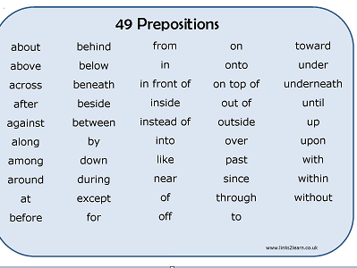

Thursday
Planet ZOGG is inhabited! Unknown to you, they are watching you as you explore their planet! What do you think the aliens would think of mankind? What would their conversation be like? It might depend on whether you think the aliens are friendly!
Write a conversation which might happen between two of the aliens as they watch the spacecraft land and the astronauts emerge.
Don’t forget to use speech marks if you are writing it as a narrative conversation.

Friday –
Listen to or re read the Space Oddity song lyrics we looked at on Monday. What does happen to Major Tom at the end of the story? Share your ideas with someone.
Continue the story of Major Tom so that the reader knows what happens next. Try to make your story as exciting as possible. You should aim to write at least two paragraphs starting from the point where contact is lost between Ground Control and Major Tom.

Foundation Subjects:

- Biomes
This term we have been finding out about Biomes. Work through the PowerPoint presentation provided. What sort of climate matches each biome? Fill in the table below.
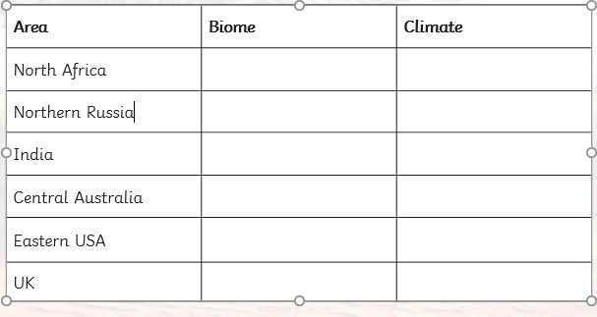

Choose one of the biomes. Imagine you are there. Write a postcard home which describes the surroundings and the climate. Make sure you include as much detail as you can.

POST CARD

- Music – Dance – create a 1 minute dance routine to go with your favourite song. Teach it to someone in your family. If you want, you could film it and send it to us!

- RE– what is it like to be a Sikh? Watch the video and then write a summary of the main points in the video. Your summary should be in the form of a short paragraph.
https://www.bbc.co.uk/teach/class-clips-video/religious-studies-ks2-what-is-sikhism/zn4h382
Can you match up the general terms with the Sikh equivalent?

Guru
Scripture
Waheguru,
God
Guru Granth Sahib
Place of worship

Gurdwara,
Service to other people
Guru

seva or langar
Spiritual leader

- DT – make a marshmallow catapult
https://www.bbc.co.uk/teach/terrific-scientific/KS2/zr63d6f
Look at this website to give you inspiration for your own marshmallow catapult! You may need to scroll down to see the video ‘DIY marshmallow catapult’. There are also some film clips of famous families having a go at the marshmallow challenge.
Make a catapult which will launch a marshmallow. How far can you get it to go? What do you need to do to make the marshmallow go further? Can you improve the catapult? How? Challenge someone else in your house to make one too and have a competition!

PLEASE MAKE SURE YOU HAVE ADULT SUPERVISION WHEN TRYING OUT YOUR CATAPULT!

PSHE
Watch ‘Danny MacAskill’s Gymnasium’ – make sure you watch the outtakes at the end: https://www.youtube.com/watch?v=fAEBNEscL0c
Goals, Inspiration and Effort:
Discuss the following with a family member, or think about…
…what you are inspired to achieve, e.g. at school? in sport? in art? in science? in life? special skills?

Have a think about the amount of effort that Danny MacAskill puts in to make these tricks work.
Consider how long it takes to perfect the trick and whether he ever gives up.
If he gives up, what reason does he give?
Do you know of any other sportsmen or sportswomen or other teams who have achieved remarkable things?
Think about Ronaldo’s high flying header: https://www.youtube.com/watch?v=B1ktbeMxtYM
Eliud Kipchoge’s 2 hour marathon: 1:59:57: https://www.youtube.com/watch?v=Dg_kdbGXU5o
Yuki Kadono’s Snowboarding Slopestyle win: https://www.youtube.com/watch?v=HlLZKTa9SGI
The team that released Giant Panda Zhang Xiang (said ‘Jan Sharn’) into the wild: https://www.youtube.com/watch?v=N6FOikMr6lY
What characteristics did it take to achieve these feats / goals?
What other support or strategies might they have needed to achieve their goals?
Would you consider any of these people to be risk takers or that their actions are foolish in any way?
What motivates these people?

