Year 5 Week 12: 13th to 17th July 2020
Reading Tasks
Read a book of your own choice for 20 minutes a day.

Reading Comprehension: to be found on school website as usual
The Selfish Giant
A Puncture
The Umbrella Mouse
When answering Reading Comprehension questions, remember to give a full answer using APE (Answer the question, Prove your answer with evidence, Explain how your evidence backs up your answer). For example:
P
A
The students have considered all the options for the playground. In the text, it says that they took the time to look at catalogues of play equipment which shows that they have been thorough in their research.
E

Writing Tasks
Monday
What are your favourite (or least favourite!) memories from the time you spent in Year 5?
Make a list of at least 4 things you remember. Why do you remember these things so clearly? For each ‘memory’, fill in the chart below. An example is given for you.
Memory | Comments – what do you remember?
Going to swimming lessons | - The coach trip – noise and chatting  - Changing and losing my shoes  - Swallowing lots of water  - The fun games we had in the water – races. I won!
Memory | Comments – what do you remember?

Tuesday:
Using your notes from yesterday and the sentence starters given, write a MY MEMORIES OF YEAR 5 report. You can choose how you lay it out on the paper. You MUST, however, write in detail about what you remember and why you recall it so well.
Possible sentence starts:
I remember really well the time when…..
When I think back……
Another thing that stays in my mind is….
I’ll never forget when……
One of the best things about year 5 was when…..
I felt so happy when….
One of my favourite memories is of…..

Don’t forget to describe the memories in detail – include how you felt, what you did, why it is so memorable! The 5 ‘W’’s are important – who, when, where, what, why (and how)!

Wednesday:
You are an expert now at being in year 5 but can you remember how you felt right at the start of the year? What do you know now that you think would be useful for the new Year 5 to know?
Write an INTRODUCTION and TIPS FOR BEING IN YEAR 5 leaflet.
You could include information about:
- Expectations
- Organisation
- Responsibilities
- Behaviour
- Things to remember
- Time table differences / what you might learn about
- A list of ‘Do’s and Don’ts’

Thursday:
If you ran the school and could make any changes to how children learn, what would be different? How would the classroom be different? What would it look like? What equipment would be used and available to all children? Would there be a teacher? Where would pupils sit? Would they sit at all? What furniture would be needed? What about books?
Design a new learning environment which you think would increase the motivation and enjoyment of children at school. It MUST however, be an educational experience – so learning has to take place! Annotate your design in as much detail as possible.

Friday:
Write a description of what your new school environment would be like. You can use ideas from yesterday and add extra information as you think of it. Remember, it must be a school, so learning has to take place! Otherwise, money is no object and so you can have any sort of equipment and furniture/space you like.
You never know, if you have really good ideas and explain why it will benefit the school, Mrs Butler-Willis might make changes to South Lake! If you can, email your work to us so that we can show her.

Foundation Subjects:
DT: Make a model of your ideal learning environment/classroom. Take a photograph and send it into school.
PSHE / Art:
Using the template below, create a Lockdown Memories Picture: You can write or draw whatever you have done during Lockdown. Remember to colour the WHOLE thing in.
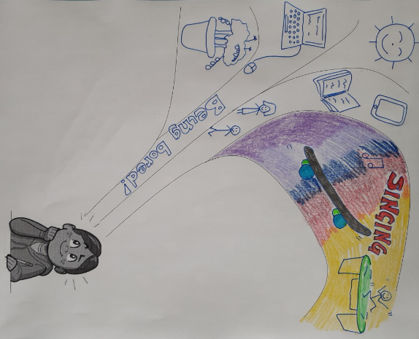
Here is an example which I started… this is not finished, as you can see, because only a small section is coloured in.
Remember to draw yourself in the box at the bottom and put your name in your picture, anywhere you like.
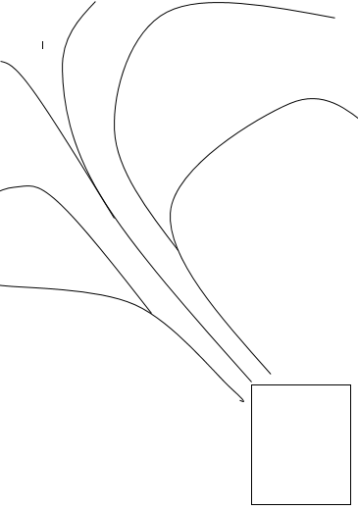

Geography – The Amazon River:
Can you use the definitions of these river features to label the diagram of a river?
Also, watch these videos to help you:
- River Features (some) https://youtu.be/7kgQNRQjIUU
- The River Severn from Source to Mouth https://www.youtube.com/watch?v=yyMJDZOM7XI
Tributary – smaller streams that flow into the main channel
Confluence – where two rivers, of approximately the same size, join together
Delta – silt or dirt carried down the river forming a land mass in the mouth of the river
Estuary – where the river widens are starts to mix with the sea
Floodplain – flat land beside the river that has a high chance of flooding
Levee – an embankment built to prevent flooding
Meander – a bend or loop in the river
Mouth – where the river ends at the sea, a lake or a larger river
Oxbow lake – a lake formed when a meander is cut off from the main river
Source – the river’s origin (where the river starts)
Waterfall – water falling from a height
Main channel – the main water flow of the river
When you have labelled your river, colour it in.

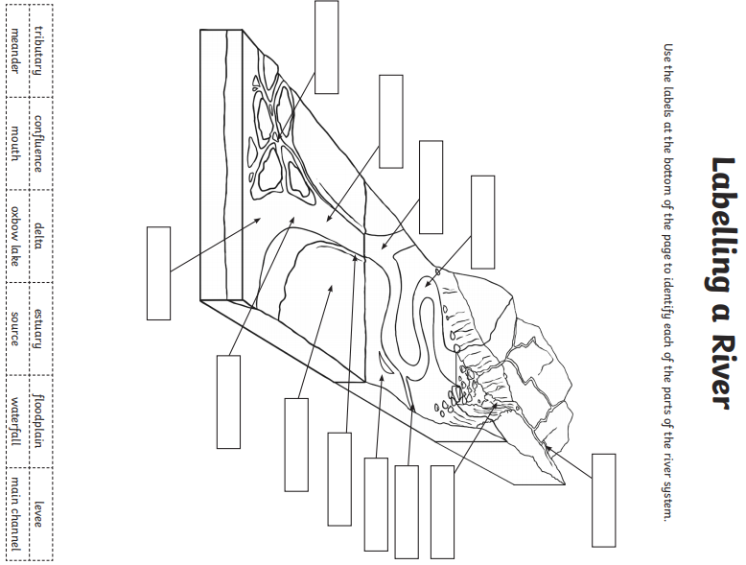

PE – Yoga:
Have a go at the Yoga poses.
Breathe deeply during each pose.
Concentrate on the areas of your body that should benefit from each pose (explained in the attached sheet).
Think about your breathing and about something that you have enjoyed or has made you laugh or feel happy.
Make sure you take it easy and don’t overstretch your muscles.

See if you can find a calm and organised way to move from one pose to another.
Create a routine.

ORACY:
Be a performer: Show your routine to others…
…Or a teacher: teach your routine to someone else.
Bow pose
Bow Pose stretches the entire front of the body, while simultaneously strengthening every muscle in the back. This improves posture and spinal flexibility. Additionally, the pose helps to open the chest, abdomen, quadriceps, ankles, groins, hip flexors, and throat.
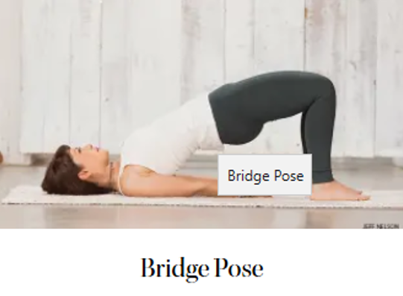
Bridge pose
Opens chest, heart and hip flexors. Stretches the chest, neck, shoulders and spine. Calms the body, alleviates stress and mild depression. Stimulates organs of the abdomen, lungs and thyroid

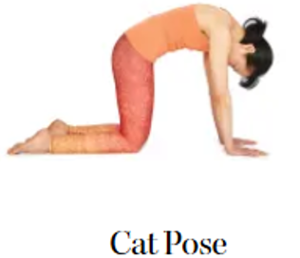
Cat pose
Cat Stretch held at its peak releases tension of the upper back and neck.
Cobra pose
Cobra Pose is best known for its ability to increase the flexibility of the spine. It stretches the chest while strengthening the spine and shoulders. It also helps to open the lungs, which is therapeutic for asthma. This pose also stimulates the abdominal organs, improving digestion

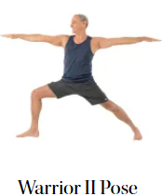
Warrior II pose
A powerful stretch for the legs, groins, and chest, Virabhadrasana II also increases stamina. It helps to relieve backaches, and stimulates healthy digestion. This is a deep hip-opening pose that strengthens the muscles in the thighs and buttocks
Cow face pose
By equally lengthening and opening both sides of the body, it helps to correct posture and regain balance between the left and right sides of your body, and the top and bottom. Sitting upright with your spine aligned calms the mind and reduces stress, anxiety, and fatigue.

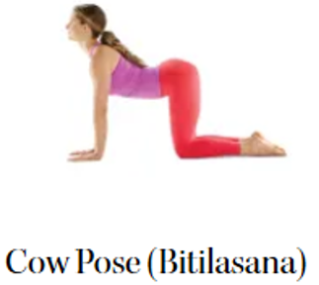

Cow pose
Cow Pose increases flexibility of the neck, shoulders, and spine. The movement also stretches the muscles of the hips, back, abdomen, chest, and lungs.

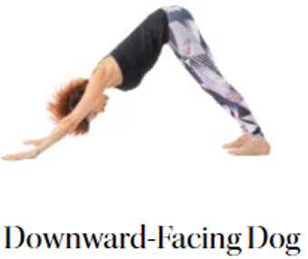
Downward-facing dog pose
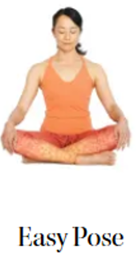
The role of downward facing dog is vast. Done properly and consistently, the most noticeable benefits include: Stronger hands, wrists, low-back, hamstrings, calves and Achilles tendon. Decrease in back pain by strengthening the entire back and shoulder girdle.
Easy pose
Strengthens the back and stretches the knees and ankles. It also opens the hips, groin, and outer thigh muscles (abductors). Sitting upright with your spine aligned also reduces stress and anxiety.

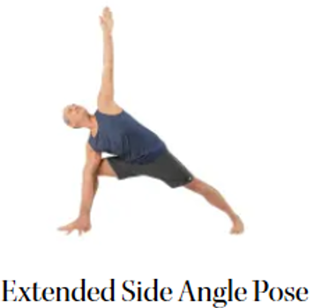
Extended-side angle pose
Relieves stiffness in the shoulders and back. It provides a deep stretch to the groins and hamstrings, and it also improves stamina. This pose strengthens the legs, knees, and ankles, while also stretching and toning the abdominal muscles.

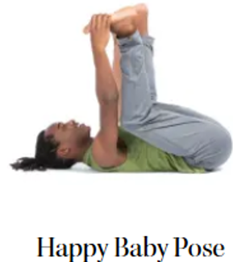

Happy Baby pose
Helps relieve stress. Increases vitality. Gently stretches low back. Opens groin and inner thigh.

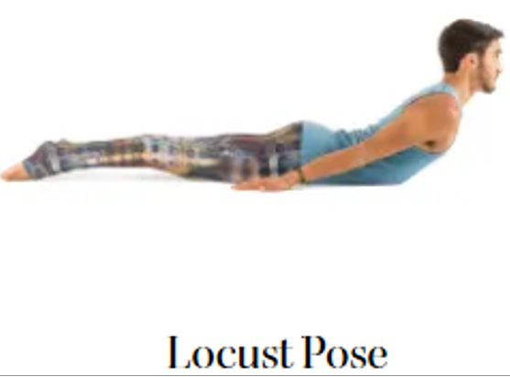
Locust pose
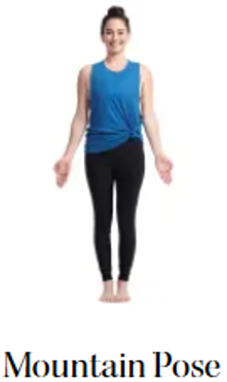
Strengthens and increases flexibility throughout the entire back of the body, including the spine, legs, buttocks, and all of the muscles surrounding your ribs and upper torso. Working the upper back muscles improves posture and helps relieve stress and fatigue caused by slouching forward.
Mountain pose
It improves posture and, when practiced regularly, can help reduce back pain. This pose strengthens the thighs, knees, ankles, abdomen, and buttocks. It is also helpful for relieving sciatica and for reducing the effects of flat feet.

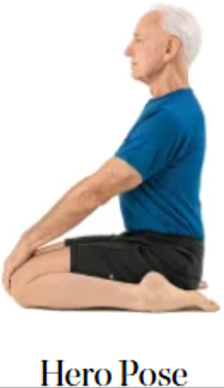

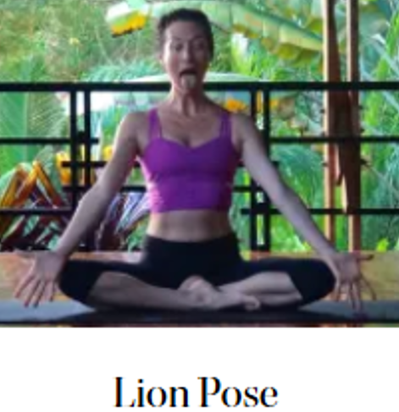
Hero pose
Hero Pose stretches the quads and ankles, helping build flexibility in the knees, ankles, and thighs. For cycling and other quad-intensive activities, the stretch will be welcome. The spinal alignment in Hero Pose is a good counter to slouching posture and allows for better breathing.
Lion pose
Lion pose strengthens the lungs, throat, and voice. This posture stimulates the tonsils and the immune system and helps to reduce stress and anger.

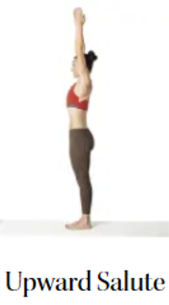
Upward salute pose
Stretches the sides of the body, spine, shoulders, armpits, and belly. It tones the thighs, improves digestion, and helps to relieve anxiety and fatigue. It also helps to create space in the chest and lungs, which is therapeutic for asthma and congestion.
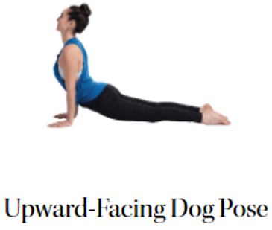
Upward-facing dog pose
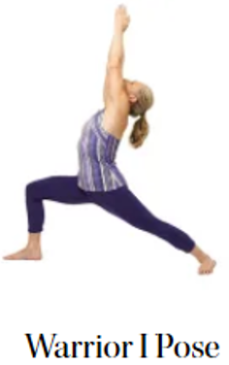
Stimulate the organs of the abdomen. Improve posture, by stretching anterior spine and strengthening posterior spine. Stretch chest and lungs, shoulders and abdomen. Help to relieve depression, fatigue and pain of sciatica.
Warrior I pose
Strengthens your shoulders, arms, legs, ankles and back. Opens yours hips, chest and lungs. Improves focus, balance and stability. Encourages good circulation and respiration.

